MANCHESTER JOINT STRATEGIC NEEDS ASSESSMENT

Serious Violence
January 2025
1. WHY IS THIS TOPIC IMPORTANT?
Serious Violence has been and remains a key priority area for Manchester’s Community Safety Partnership (CSP), and links closely with work being done at a Greater Manchester and national level. The Greater Manchester Violence Reduction Unit (VRU) has developed a strategy for Greater Manchester but due to the increases and concerns relating to serious violence in the city of Manchester, and the implementation of the Serious Violence Duty (SVD), a separate strategy informed by this Needs Assessment, is necessary.

Serious violence has significant and lasting social and economic impact. It is estimated that a homicide costs the public purse an average of £3,217,740 It is argued that the cost of implementing support at the earliest opportunity to prevent people from becoming involved in criminality is substantial but, the costs would be less if we could intervene earlier and prevent people entering the criminal justice system.

1.1 Legislation

On 31 January 2023 the SVD came into effect in England and Wales under Chapter 1, Part 2 of the Police, Crime, Sentencing and Courts Act 2022.

The SVD requires Specified Authorities (Local Authorities, Police, Justice, Fire and Rescue and Health) to collaborate to prevent and reduce serious violence. This includes the identification of the types of violence, the cause of violence (as far as possible to do so) and to prepare and implement a response strategy at a local level.

1.2 Public Health Approach

The SVD encourages Specified Authorities to adopt the World Health Organisation’s definition of a public health approach, when looking at how to identify types and causes of violence to inform their response strategy.

The World Health Organisation’s definition of a Public Health approach can be summarised as follows: -

• Focused on a defined population
• With and for communities
• Not constrained by organisational or professional boundaries
• Focused on generating long term as well as short term solutions
• Based on data and intelligence to identify the burden on the population, including any inequalities
• Rooted in evidence of effectiveness to tackle the problem

Serious violence is an issue befitting a public health approach and evidence from other public health approaches has shown reductions after time. All partners have an important role to play in prevention, intervention and support to address this issue.

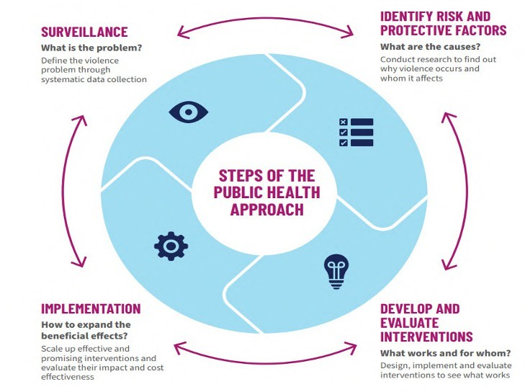

The SVD recognises the need for tough law enforcement in relation to serious violence but also places a strong focus on understanding the nature of serious violence and its underlying causes at a local level.

1.3 Compliance with the Violence Duty

Through the work of Manchester’s Serious Violence Board Manchester is compliant w with the SVD through its co production and publication of the Manchester Serious Violence Strategy 2024 - 2027. The SVD further requires specified authorities to review their local needs assessment and strategy on an annual basis. The work undertaken by specified (and required) authorities in the Serious Violence Board, is overseen by CSP Board.

To adhere to Greater Manchester’s approach to the implementation of the SVD, Manchester’s Serious Violence Board / CSP will conduct this review of the Joint Strategic Needs Assessment (JSNA) by 31st January 2025. The JSNA will then be reviewed in conjunction with our existing Serious Violence Strategy to determine if any amendments are required.

1.4 Defining Serious Violence

The Police, Crime, Sentencing and Courts Act (PCSC) 2022 does not define serious violence for the purpose of the SVD.

The World Health Organisation (WHO) defines serious violence as” The intentional use of physical force or power, threatened or actual, against oneself, another person or against a group or community, that either results in or has a high likelihood of resulting in injury, death, psychological harm, maldevelopment or deprivation” Source: World Health Organisation.

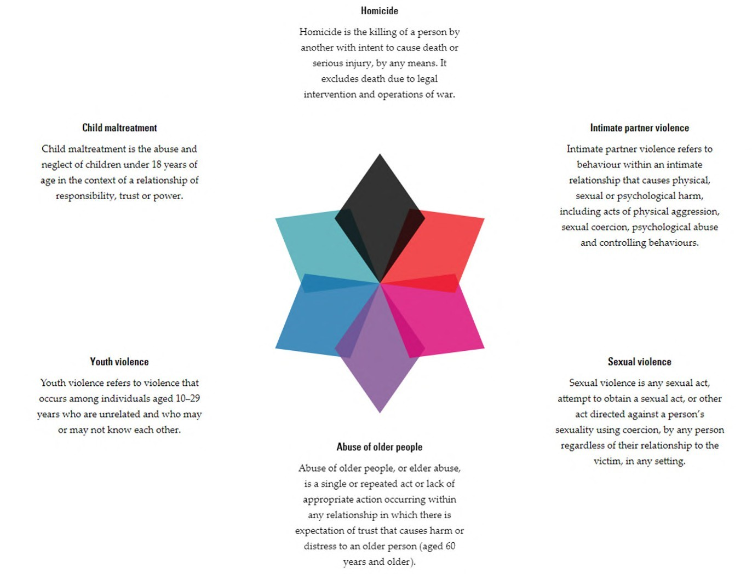

The SVD guidance does state that serious violence can be defined at a local level but must consider the following factors listed in Section 13(6) of the PCSC Act: -

- The maximum penalty which could be imposed for any offence involved in the violence.
- The impact of the violence on victims
- The prevalence of violence in the area
- The impact of violence on the local community

Specified Authorities are encouraged to consider whether the following types of violence amounts to serious violence in their local area: -

- Domestic abuse
- Sexual abuse
- Violence against property
- Threats of violence

The guidance also states that those responsible for discharging the duty locally should focus on: -

- Public space violence linked involving children and young people
- Violence against the person – which may include both knife crime and gun crime
- Areas of criminality where there is an inherent threat of violence, such as county lines drug dealing.

The SVD allows flexibility when defining serious violence to include: -

- Alcohol related violence
- Criminal exploitation (of both children and adults)
- Modern Slavery
- Violence against women and girls (VAWG), including domestic abuse
- Sexual offences
- Male and LGBTQ+ victims.

For this JSNA Manchester’s Serious Violence Board has decided to adopt the WHO definition of serious violence. Manchester’s Serious Violence Board has considered the guidance and agreed that due to the significant pieces of work being undertaken in the city in relation to Domestic Abuse and Violence Against Women and Girls Domestic Abuse will not be priority of this needs assessment. However, the Serious Violence Board does recognise the overlap in these areas and the CSP has oversight in relation to these areas of work.

The Manchester Domestic Abuse Strategy can be found here - Making Manchester Safer

1.5 Greater Manchester Violence Reduction Unit (VRU)

Established in October 2019, the Greater Manchester VRU is a team of subject leads and experts from the police, probation, public health, health, education, community and voluntary sector, youth justice and local authorities, working together to address the underlying causes of violence and working with communities to prevent it.

The VRU in Greater Manchester is one of twenty VRU’s across the country. The VRU, through Greater Manchester’s Mayor and the Deputy Mayor for police, crime, fire and criminal justice, launched its Serious Violence Action Plan in the summer of 2020. This action plan sets out seven priorities based on its local data, intelligence and local voices within communities.

In December 2023, Greater Manchester VRU published their ten year Greater Than Violence strategy. The Greater Than Violence strategy commits to working together with individuals and communities to understand their strengths, challenges, and ideas to tackle violence.
Led by the Mayor and Deputy Mayor of Greater Manchester, the Greater Than Violence strategy works to improve lives by preventing violence, supporting victims, families and communities affected, and providing positive opportunities to those at risk of becoming victims, witnesses, or perpetrators, including education programmes, community sports, targeted mentoring, opportunities to develop new skills and therapeutic support.
The strategy is founded on two pillars: preventing violence from happening and responding swiftly and appropriately when it occurs. A copy of the Greater Than Violence strategy can be found here - Greater Than Violence Strategy - Greater Manchester Violence Reduction Unit

1.6 Local Governance (Manchester)

Governing a partnership approach to serious violence is essential to the delivery of this strategy, and the SVD, as no one organisation can resolve the problem alone.
Manchester’s Serious Violence Board will ensure effective oversight of responses to serious violent crime (ensuring prevention, early intervention and safeguarding are integrated to our responses) in the City of Manchester. The Board will oversee the implementation of a public health approach and drive to support partnership working to ensure visibility for overlapping areas such as safeguarding.

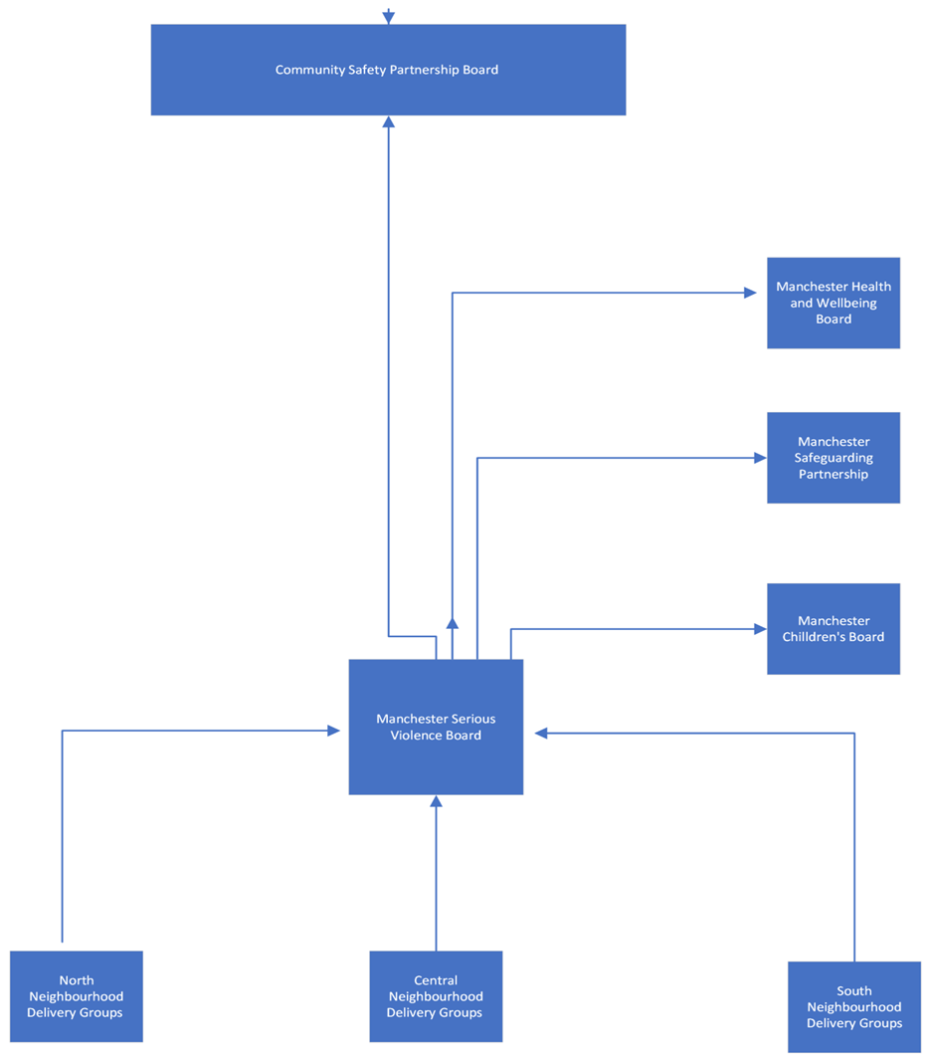

2. THE MANCHESTER PICTURE
The Manchester picture: data

2.1. Demographic data (MCC PRI team) -

- The population of the city, as at Census 2021 was 551,938 (the 2021 Census missed a significant number of residents due to COVID19, MCC estimate the current 2023 population to be nearer 600,000), of which:
- 49.7% are male and 50.3% female
- The city has a relatively young population, with 31.9% aged between 19 and 34 and with the city’s 59,676 students¹ accounting for 33.9% of this age group
- 9.5% of the population are 65 and over
- 23% are under 18

According to the 2021 census:

- 31.3% of the population class themselves as married/civil partnered, with almost 56% classing themselves as single
- 56.8% are White, 20.9% Asian or Asian British, 11.9% Black or Black British, 5.3% are of mixed heritage
- Just over 96,700 residents of the city see themselves as disabled
- In terms of household composition, 14.4% are lone parents, 26.6% are two parent families with children and 59% are adults with no children
- Almost 37.6% of the city’s population is educated to at least Degree/Diploma level, though 19.7% have no qualifications at all
- ONS estimate that 16% of working residents earn less than the living wage of £9.90 per hour⁴ in 2022. Census 2021 states that 30.1%³ of the population aged 16-65 are economically inactive**
- 69,571 residents were in receipt of out of work benefits⁵ in August 2022, equating to 18% of the population aged 16-64, higher than the England average of 12.4%
- The city still has significant issues of deprivation and is ranked the 6th most deprived local authority area in England (IMD 2019)
- Older people in the city have been disproportionately affected by the pandemic and the impacts of lockdown

*This figure is for those who consider themselves to have a long-term health problem or disability which limits their day-to-day activities
** Economically inactive people are those without a job who are not seeking work and/or are not available to start work in the next two weeks. The main groups are students, people looking after family and home, long term and temporarily sick and disabled, retired people and discouraged workers.

1 HESA student data 2020-21
2 End Child Poverty 2019-20
3 Census 2021
4 ONS Annual Survey of Hours & Earnings (ASHE) 2022
5 ONS Annual Population Survey
6 DWP StatXplore

2.2 Police data – Serious violence incidents and crimes - Greater Manchester Police (GMP)

Between October 2021 and September 2024, 29% of homicides and attempt murders in Greater Manchester happened within the City of Manchester, and a further 12% involved a victim or suspect linked to a home address in the city, with these cross-border offences most likely to take place in neighbouring Salford, Stockport or Trafford.
Manchester's disproportionate share of serious violence in Greater Manchester is driven by several factors, but of significance is the City Centre's status as an entertainment, retail, business, and transport hub (with the additional issues that this brings), as well as the high levels of deprivation in some neighbourhoods outside the City Centre.
15% of serious violent offences in the City of Manchester during the 12 months between October 2023 and September 2024 involved a victim or at least one suspect under the age of 18, and 27% involved a victim or suspect aged 18 to 25.
The total number of serious violent offences recorded in the City of Manchester reduced by 1% in the last 12 months (October 2023 to September 2024) compared with the previous year. This slight reduction followed on from an 8% drop during the previous year. The combined harm associated with these offences reduced by 3% in the last 12 months, on top of an 8% reduction in the previous year. Combined harm saw a larger percentage reduction than the number of offences due to a bigger drop in homicides and attempt murders (which carry a higher harm score).
Robbery offences reduced by 13% in the last 12 months, although this overall reduction included a small rise in business robberies, mainly relating to offences committed at retail locations.
12% of the most serious violent offences in the last 12 months were flagged as domestic violence, a reduction from 16% of offences in the previous year.
2% of serious violent offences were flagged as hate-motivated crimes.
Alcohol was identified as a factor in two in every ten of the most serious violent offences, rising to three in every ten offences which took place in the City Centre, or which were flagged as domestic violence. 5% of crime reports identified drugs as a contributory factor.

There are strong correlations between deprivation and levels of serious violence
Victims and perpetrators of serious violence in Manchester are more likely to live in more deprived parts of the city. In the 2019 English Indices of Deprivation, 43% of Manchester LSOAs were calculated to be in the most deprived 10% nationally, but this was true for 64% of SV suspects and 61% of SV victims who were living in Manchester and linked to offences between October 2021 and September 2024.
This correlation is also present in relation to violent crime more generally, although links to deprivation are slightly less true in the case of victims of violence aged 18 to 25, and slightly more true of the very youngest suspects linked to these offences (those aged 10 to 13).
For robbery victims the link with deprivation is generally somewhat weaker.
Hotspot areas / repeat locations including Piccadilly Gardens (adults for City Centre wards – Young People in neighbouring wards)
19% of serious violent offences between October 2023 and September 2024 happened in the City Centre, with the police beats containing Piccadilly Gardens and the Village registering the highest numbers of reports. City Centre offences were most likely to happen in the early hours of Saturday or Sunday morning.
As noted above, 15% of the most serious violent offences in the past 12 months involved a victim and / or suspect under the age of 18. Only one in 13 of these offences happened in the City Centre, compared with more than one in four serious violent offences involving a victim and / or suspect aged between 18 and 25.
Offences involving young people were more likely to take place on the street, or in other open areas including parks and playing fields, and the relevant crime reports were also more likely to be linked to multiple suspects: this underlines the part played by groups and other affiliations in serious violence involving young people, including cases where victims have been attacked because of their friendships and other associations.
The most significant repeat locations for serious violence in the past 12 months have been HMP Manchester (19 offences) and Piccadilly Gardens (12).
The 12 months up to September 2024 also saw 29 serious violent offences linked to hospital locations (particularly North Manchester General and the MRI), but most of these reports (22 out of 29) involved victims arriving at A&E departments after being attacked at other locations. 19 of these 22 offences involved assaults with knives or similar weapons, with 55% of these A&E victims aged 25 or under, compared with 31% of SV victims overall. (The fact that some serious assaults are only discovered when victims attend A&E out of necessity, and then often refuse to reveal any details of the attack or attackers, may point to a significant degree of under-reporting of other incidents which do not require such emergency treatment).
The vast majority of victims of serious violence assaults are male
75% of victims of serious violence during the past two years were male, including 77% of homicide victims. Males were also more likely to become victims of personal robbery, in 80% of cases.
The age profile of victims of serious violence Manchester is relatively young
Victims of serious violence in Manchester are most likely to be aged between 20 and 30. This is partly due to the age profile of Manchester’s population (which increases dramatically from the age of 19 onwards) and partly due to adult victims travelling into the city from other areas.
In terms of rates by population, the age group most at risk of becoming victims of serious violence amongst Manchester residents are those aged 14 to 17. This risk relates particularly to young men: the risk profile by age for women resident in Manchester is more dispersed across a broader age range.
Repeat victimisation is a significant issue across the city
25% of victims of serious violence in Manchester between October 2023 and September 2024 had already been the victim of a violent crime during the previous 12 months. This increased to 34% of victims of serious assaults classified as domestic violence.
Repeat offending
60% of suspects linked to serious violent offences between October 2023 and September 2024 had already been linked to another offence in the previous 24 months, and 54% had been already linked at least one violent offence over the same period.
Of 574 suspects currently linked to serious violent offences in the most recent 12 months, 45 had already been linked as a suspect to serious violence in the preceding two years, and 144 had already been linked to a previous offence of violence with injury in the same date range.
Some serious violent offenders have been linked to large numbers of violent offences during the past three years, with 115 individuals having each been linked to 10 or more offences against the person, possession of weapon, or public order, with domestic violence being a significant factor in many of the more prolific cases.
The vast majority of perpetrators of serious violence are male
82% of perpetrators linked to serious violence in Manchester in the past three years have been male, and this share has remained relatively consistent from year to year (within one or two percentage points).
The age profile of perpetrators of serious violence
Perpetrators of serious violence of the past three years were most likely to be aged between 16 and 30, and this 15-year age band accounted for nearly half of all offenders (46%).
Robbery offenders occupied a much narrower age range, with just under a third of all suspects being aged between 14 and 17, and half being aged between 13 and 22.
Home addresses of individuals linked to serious violence
Two thirds of victims of serious violence in Manchester over the past three years had home addresses within the city, with a further quarter living in other parts of Greater Manchester, and others living further afield.
Perpetrators of serious violence were more likely to live in the city, with 7 in 10 suspects living in Manchester, and a further 2 in 10 living in other parts of Greater Manchester.
Robbery suspects and victims were both slightly more likely to live outside the city, probably because this type of crime is less likely to involve domestic violence and domestic locations.
Serious assaults in the City of Manchester are more likely than other districts to involve people who live outside its borders, with only Trafford amongst GM districts seeing a higher rate of influx.
There are some links between serious violence and Manchester’s Street Community
Manchester City Centre has a substantial street community, who may have additional vulnerabilities (substance abuse, housing needs, healthcare needs etc.), and this is an additional risk factor in relation to serious violence. On the A2H1 Piccadilly Gardens beat, over a three-year period, 13% of individuals linked to serious violence as suspects were identified as members of the street community, as were 12% of victims.
Weapons used in serious violent assaults
36% of serious violent offences in the past 12 months involved the use of a knife or other sharp or bladed weapon, but this was more likely to be the case with offences involving younger individuals. Knives featured in 54% of offences with a victim or suspect under the age of 18, and in 44% of offences with a victim or suspect aged 18 to 25. Knives were less likely to feature in offences classified as domestic violence (in only 9% of these cases).
Offences committed in the City Centre were more likely than other serious violent offences to involve the use of bottles or glasses as weapons. 35% of offences involving these weapons happened in the City Centre.
TIIG A&E data (Trauma & Injury Intelligence Group)
The Trauma & Injury Intelligence Group collates data from A&E departments across the North-West relating to assaults and other injuries.
Between October 2023 and September 2024, 1596 A&E attendances due to assault were recorded for Manchester residents, with 84% of these being linked to the three main Manchester hospitals. This total represented an 8% increase from the number of attendances recorded in the previous 12 months.
Two thirds of attendances in the most recent 12-month period involved a male victim, but the majority of the increase in this period related to a rise in the number of female attendees.
The highest volumes of attendances were seen amongst patients aged 18 to 30, but this pattern is partly influenced by the age profile of Manchester’s population. When adjusted for population size, the highest risk relates to those aged 14 to 17 (the same group identified as the highest risk in police data).
According to the available data, residents of Asian ethnicity were less likely to attend A&E due to assaults than other groups.
The home addresses of assault patients in the TIIG data continue to demonstrate a strong correlation with deprivation. As noted above, in 2019 43% of Manchester LSOAs were calculated to be in the most deprived 10% nationally, but this was true for 61% of Manchester residents who attended A&E because of assault between October 2021 and September 2024 (the same proportion as for SV victims over the same period).

2.4 Manchester Youth Justice Data

Serious Violence involving children and young people Statistics – Manchester Youth Justice: -

- 41 young people charged with Serious Violence category offences between 1 April 2023 and 31 March 2024.
- 69 Serious Violence offences for the same timeframe (78.3% Robbery, 11.6% violence against the person and 10.1% related to drugs offences).
- 58.5% of young people charged with a Serious Violence offence are from Black Asian or Minority Ethnic Community [34.1% White, 7.3% Other/Unknown] (For context, Youth Justice Cohort as at end of 2023-24 Q4: 53.7% Black, Asian, or Minority Ethnic, 44.4% White, 1.9% Unknown)
- 4.9% of young people charged with a Serious Violence offence are female [95.1% male] (Youth Justice Cohort as at end of 2023-24 Q4: 15.1% female, 84.6% male, 0.3% non-binary)
- SV offenders by age:
o 10-14: 26.8%
o 15: 19.5%
o 16: 26.8%
o 17+: 26.8%
Average age of Youth Justice cohort at end of 2023-24 Q4: 15.9 years of age.

2.5 Manchester Probation data

This following information is based on a snapshot of the caseload for Manchester Probation taken in June 2023
- 93% of orders/licences for Serious Violent Offences (SV) were Males. 7% females (2125 Orders/Licences)
(Census 2021 Data suggests an approximate 50/50% split Male/Female). The reasons for male involvement in serious violence and criminality in general are well documented.

- For 68% of males on an order or Licence for an offence of serious violence, it was their first time on probation although this does not mean it was their first offence per-se. Predictably for males, the higher their age group, the less likely it would be that an offence of serious violence would be their first time on probation. From the peak of 68% this steadily decreases so that in the 35+ year group, only 22% of orders given for serious violence, where the perpetrator is male, was it their first time on probation.

- The female timeline is less linear. For example, the peak age for females being on probation for the first time is 22-25 and this then falls and then rises over the age categories. The age groups versus the percentages where this was the first order with probation are as follows:- 18 to 21= 50%, 22 to 25= 63%, 26 to 35= 27%, Over 35= 41%. This is reflective of the distinct differences in the underlying reasons for offending between Male and Female offenders.

- The category with the highest number of offences committed by Males was ‘Malicious Wounding and other like offences’. This accounted for 506 of all Serious Violent Orders/Licences (out of 1988). However, it should be noted that this category is an umbrella definition for a number of offences such as Actual Bodily Harm, possession of bladed articles, Wounding, Grievous Bodily Harm, breach of restraining orders etc. For males, the next top 5 serious violent offences were Robbery (285), Common Assault (235), Murder (201), Wounding (186) and Rape (154).

- For Females, again ‘Malicious Wounding and other like offences’ accounted for 46 of all Serious Violence Orders/Licenses (out of 137). For Females the other significant categories for serious violence were Common Assault (26), Assault on Emergency Workers (25), Wounding (10), Robbery (8) and Murder (7).

It should be noted, that for the above 2 paragraphs, the more serious the offence, the longer the sentence and therefore, this will affect the overall percentages of people on probation with any offence type.

- Murder and Manslaughter (for females) and Murder, Manslaughter and Rape (For Males) – Statistically, these were more likely to be first offences (subject to the proviso that although the first order/licence with probation- they may have had previous orders as youths). This ranged from 40% to 70%.

In terms of Ethnicity, I have compared the Probation caseload for serious violence (first figure) with the census data provided within the JSNA report (Second).

Total Caseload = 2125
White- 60% (56.8%)
Asian or Asian British- 8% (20.9%)
Black or Black British- 15% (11.9%)
Mixed Heritage- 9% (5.3%)

The most significant positive difference between population is that of the Asian or Asian British population which suggests that this ethnic category accounts for nearly 21% of the Manchester population but only accounts for 8% of serious violence orders or licences. This marked difference may be worthy of further research in order to examine protective factors against serious violence. It is also evident from these figures that Black/Black British and Mixed Heritage groups are overrepresented. A Greater Manchester probation report on disproportionality suggests that the reason for this over-representation is the predominant type of offences committed by different ethnicities of offenders and hence longer sentences which leads into being on probation for longer periods of time.

2.6 Exclusions Data – Suspensions and Permanent Exclusions
Note: All exclusion data is published by the DfE and is one academic year in arrears

 |  | 2021/22 | 2022/23
Manchester | Suspensions | 7,291 | 10,991
Manchester | Suspension (rate) | 7.97 | 11.84
Manchester | Permanent exclusions | 71 | 102
Manchester | Permanent exclusions (rate) | 0.08 | 0.11
National | Suspension (rate) | 6.91 | 9.33
National | Permanent exclusions (rate) | 0.08 | 0.11
North West | Suspension (rate) | 7.12 | 9.23
North West | Permanent exclusions (rate) | 0.11 | 0.16

- Suspensions and permanent exclusions in Manchester increased between 2021/2022 and 2022/2023 which follows an upward regional and national trend.
- Suspensions increased in number by 51%
- Permanent Exclusions increased in number by 44%
- When comparing rates of suspension (rates are based on pupil population per 1,000) Manchester is higher than both regional and national data sets.
- However, when comparing rates of permanent exclusion (rates are based on pupil population per 1,000) Manchester is in line with national data and lower than regional local authorities. This suggests that Manchester schools are more likely to use suspension as an alternative to permanent exclusion.

2022/23 (selected reasons for Permanent Exclusion- % of all PEX in area)
Manchester | Permanent - Drug and alcohol related (%) | 3.6%
Manchester | Permanent - Persistent disruptive behaviour (%) | 40.4%
Manchester | Permanent - Physical assault against a pupil (%) | 17.7%
Manchester | Permanent - Physical assault against an adult (%) | 13.5%
Manchester | Permanent - Use or threat of use of an offensive weapon or prohibited item (%) | 5.7%
England | Permanent - Drug and alcohol related (%) | 4.6%
England | Permanent - Persistent disruptive behaviour (%) | 38.5%
England | Permanent - Physical assault against a pupil (%) | 15.3%
England | Permanent - Physical assault against an adult (%) | 11.9%
England | Permanent - Use or threat of use of an offensive weapon or prohibited item (%) | 5.3%
North West | Permanent - Drug and alcohol related (%) | 5.5%
North West | Permanent - Persistent disruptive behaviour (%) | 41.1%
North West | Permanent - Physical assault against a pupil (%) | 13.6%
North West | Permanent - Physical assault against an adult (%) | 10.2%
North West | Permanent - Use or threat of use of an offensive weapon or prohibited item (%) | 5.1%

- The above table has selected reasons for permanent exclusion linked to serious violence. It shows the % against all exclusions in the area.
- There are no outliers when comparing data to other areas although physical assaults against both adults and pupils has been a growing reason for permanent exclusion with higher rates in Manchester when compared to other local authority areas.
2.7 Complex Safeguarding Hub –
Manchester’s Complex Safeguarding Hub (CSH) works with young people at risk of exploitation, providing tailored interventions based on trusted relationships and trauma-informed approaches. The team collaborates closely with multi-agency partners to develop effective, joined-up safety plans, supporting young people to realise their aspirations and achieve positive outcomes.
The CSH is intelligence-led, adapting to emerging trends and patterns of exploitation by analysing referrals and other sources of information. The service is guided by an evolving understanding of trauma and the vulnerabilities that increase the risk of exploitation, ensuring that children receive the right intervention at the right time. Strong connections across the partnership are vital to achieving this, and awareness-raising, guidance, and training are key aspects of the CSH’s work to enable the identification, assessment, and delivery of support for victims.
The CSH is co-located at Greenheys Police Station. The team structure, detailed in the annual report, includes specialist social work and police teams, a senior safeguarding nurse, a dedicated Early Help Team, a Trusted Relationship Clinical Psychologist, and a Missing from Care Team commissioned by The Children’s Society, alongside an MCC Missing from Home Team. The hub also maintains strong links with Youth Justice, whose representatives attend daily risk meetings, and Adult Social Care, which has a dedicated worker from the Adult MASH team linked directly to the CSH.
To deliver high-quality responses for children at risk of exploitation or serious violence, the CSH employs a practice model focused on prevention, assessment, and bespoke support packages. Preventative work includes awareness-raising and providing guidance and training to professionals. The Early Help and Missing from Home and Care teams support children and families who may not have a social worker but show signs of vulnerability.
Children referred to the CSH are discussed at a daily multi-agency meeting, where decisions are made based on shared information. Social workers carry out detailed assessments to understand the risks of exploitation and the factors affecting each child’s vulnerability. Interventions are then planned collaboratively, focusing on the child’s needs and wishes. These interventions are child-led, trauma-informed, and built on trusted relationships.
The CSH model is effective in ensuring joint information sharing and planning, with a strong emphasis on disrupting perpetrators. Police and social workers collaborate to identify opportunities for disruption, and joint operations are carried out in complex cases. These operations are effective responses to investigations involving multiple perpetrators or victims.

IN 2024, the demand for the service increased significantly: and includes children who are involved in serious violence.
- 272 referrals were made to the CSH.
- 64% of referrals (165) were related to criminal exploitation, and 20% (53) were related to sexual exploitation.
- 69% of referred children were male (167), while 31% were female (75). Among those referred for Child Criminal Exploitation (CCE), 64% were boys. For Child Sexual Exploitation (CSE), 20% were girls.
- Only 3% of referrals involved black, shared heritage girls at risk of any exploitation type. This highlights a disproportionate number of concerns related to CCE and serious violence, particularly among boys from dual/shared heritage and black backgrounds.
- 68% of referred children were aged 15–16 years (118), 28% were aged 13–14 years (77), 6% were aged 11–12 years (17), and 2% were under 11 years old (6). Additionally, 18% were aged 17–18 years (56).
- In terms of ethnicity, 42% were white, 10% Asian, 19% black, 26% Shared heritage, and 3% other ethnicities.
- 39% of referred children had additional needs, including special educational needs or learning disabilities (94).

Between 2022 and 2024, the CSH made concerted efforts to address gender disparities and improve cultural awareness. These efforts included training for staff to enhance their understanding of cultural contexts and the unique challenges faced by black girls. Training focused on recognising signs of exploitation that might otherwise be overlooked due to cultural biases or stereotypes.
The CSH also launched a week of targeted actions, engaging schools, health services, foster carers, and youth centres to raise awareness. Quarterly training sessions were delivered to school safeguarding leads, and direct engagement with children and young people was prioritised. These measures led to a slight increase in referrals for girls, reflecting improved awareness and identification.
The CSH acknowledges that some of the challenges stem from systemic biases, cultural misunderstandings, and mistrust of authorities within marginalised communities. Additionally, a lack of representation and cultural competence in safeguarding agencies can lead to underreporting or misidentification of exploitation cases.
To address these issues, the CSH has joined forces with community representatives to share intelligence and deepen understanding of risks specific to individual communities. This collaboration has strengthened the hub’s ability to respond effectively to the needs of all children at risk of exploitation and serous violence.

2.8 Trauma informed practice
According to the Centers for Disease Control and Prevention (CDC), Adverse Childhood Experiences' (ACE’s) are potentially traumatic events that occur in childhood. ACEs include, for example: experiencing violence, abuse, or neglect; witnessing domestic violence; bereavement; substance misuse within the family; mental health problems within the family; parental separation; or having a family member in prison.
The CDC Kaiser Permanente Adverse Childhood Experiences (ACE) Study originated in Southern California in the late 1990s. To this day, this study remains one of the largest investigations of childhood abuse and neglect and household challenges and later life health and well-being. The original study used a 10-point scale to investigate the prevalence of three main types of ACEs. ACEs have been shown to have lasting, negative effects on health, well-being, and opportunity. They have also been shown to have an impact on the likelihood of both future violence perpetration and victimisation. There has been a growing awareness in recent years of the importance of being trauma-informed when dealing with children who have a history of ACEs. This is especially the case with those agencies who work with justice-involved children.
In 2020 research was commissioned by Manchester City Council’s Youth Justice Service and funded through the Youth Justice Board - Reducing Serious Youth Violence to develop understanding of the drivers of Serious Youth Violence. The research brings together key areas of practice; Serious Youth Violence, ACEs, trauma-informed practice, and youth participation – to investigate the complex relationship between Serious Youth Violence and ACEs. This is detailed in the report published in 2021 which includes a number of recommendations on trauma informed practice
2.9 Peer Review Findings (Manchester Youth Justice)
A peer review of Manchester’s Youth Justice Service undertaken in November 2021 focused on four key lines of enquiry, two of these are of particular interest to understanding Serious Youth Violence in Manchester: -
Key Line of Enquiry 1: The Effectiveness of the Partnership Approach to Serious Youth Violence
Areas for consideration:
- Given the volume of Strategic Plans, Impact Assessments, Research Findings, and consultations, the partnership needs to ensure that all strategic activity is aligned. In addition, the partnership should consider providing more opportunities to ensure that all the Strategic Planning is shared, discussed, and understood across all levels of all agencies.
- The Youth Justice Management Board may wish to consider utilising the Strategic and Operational Subgroups (to the Board), where the key priorities can have shared action plans which are formulated, discussed, shared, and progressed by a mixture of partnership managers and staff. Youth Justice Management Board may wish to consider having a designated Board member ‘Owner’ for each subgroup, who is responsible for updating the Board and, where necessary, eliciting their support to help breaking down any barriers or blockages to progress.
- Although there is recognition that Transitions is a gap and work has been identified to improve this, the Youth Justice Management Board may want to consider giving this more priority. It was identified that the 18-25-year age group of young people was a particular area of concern.
- In addition to the effective partnership working between Youth Justice and The Probation Service, the partnership may wish to consider how to better align the Youth and Adult Integrated Offender Management Schemes which would allow for more seamless working particularly for those young people who have progressed in the system by virtue of committing/repeated offences involving violence. The impending requirement for local authorities to have a Serious Violence Duty being created would also be another potential vehicle to assist in a multi-agency approach, including those who transition from Youth Justice.
- The Youth Justice Management Board may wish to consider opportunities to provide further clarity at an operational level to all key agencies about the roles and responsibilities of each agency when a child is open to the Complex Safeguarding Team.
- Youth Justice Management Board partnership may wish to consider identifying how to improve the alignment between Youth Justice and other teams/services which have a focus on extra familial and contextual safeguarding featuring Child Criminal Exploitation, Child Sexual Exploitation and missing children and young people, many of whom are known currently or will be gravitating towards being open to Youth Justice. The aim being to better coordinate the efforts of all workers involved in working with the most vulnerable children and help ensure that plans are better aligned, thereby harnessing the input of all workers across a range of disciplines, including youth justice, gangs, organised crime, social care, and other key partners.
- The partnership may wish to consider if they are making the best of all the available data to ensure it has the most impact on practice, resource allocation, change and outcomes for children.
- The work of the Subgroups can allow for the scrutiny of the granularity of data to allow focus upon the key priorities, for example: reducing First Time Entrant’s; reducing reoffending; further reducing the use of custody; addressing over-representation; maximising participation and reducing serious youth violence and related Child Criminal Exploitation.

Key Line of Enquiry 3: Quality and Impact of Strategic and Operational Delivery in the Context of Equality and Reducing Disproportionality
Areas for consideration:
- Further consistency and positive practice in this area could be achieved through delivery of multi-agency training and raising awareness with other agencies and key partners within the criminal justice system.
- The Youth Justice Management Board may wish to consider how the Children’s Services Quality Assurance Framework (QAF) could be utilised or adapted to provide a focus on equality and disproportionality. Giving consideration as to how the partnership can collectively ensure racism is considered within the context of always being considered as a safeguarding issue will ensure effective safeguarding practice when addressing inequality, racism, and disproportionality.
- Manchester Youth Justice may wish to consider additional and more impactful ways of addressing the under representation of black and ethically minoritised boys receiving out of court disposals to have more of an impact sooner, and to avoid disproportionally bringing black and other minoritised children into the criminal justice system.

2.10 Strengthening Practice Review – Manchester and Trafford
A review was jointly commissioned by Manchester City Council and Trafford Council to consider the multi-agency response to three young people, two of whom were fatally injured with the third suffering serious injuries, following two separate knife crime incidents.

The review explores the young people’s journey through services, how their needs were identified and responded to and how effective the interventions were. It considers whether young people in need of protection from knife crime receive appropriate and effective interventions in a timely manner and whether services were sufficient and in line with both individual and multi-agency practice standards.

The review made the following recommendations: -

The Importance of Critical Moments

- To treat encounters with those below the age of 18, as ‘children first’ and for risk assessments to more explicitly reference vulnerability and exploitation where appropriate, including the impact of retaining drugs or money that may increase vulnerability.
- To promote the use of the National Referral Mechanism (NRM) and to review its effectiveness for vulnerable children in relation to safeguarding from criminal exploitation.
- For assessments to involve parents and wider family members, particularly fathers.

Education and Exclusions

- To review arrangements regarding fixed term and permanent exclusions in respect of decision making, thresholds and alternative education arrangements.
- To review arrangements regarding transitions and information sharing particularly when there are cross border issues.

Safeguarding Processes

- For records to accurately reflect the correct spellings of names, dates of birth, addresses and family details and for records to be updated immediately following critical incidents or changes in circumstances.
- For agency responses in terms of referral, assessment, planning and review to be in accordance with agreed practice standards and for plans to be SMART, linking with other service planning such as Youth Justice or the Complex Safeguarding Hub.
- To review the work of the ‘Complex Safeguarding Hub’ regarding the interface with Locality Teams.

Early Help and Trauma Informed Practice

- To review the arrangements for Early Help to ensure that families receive support in a timely manner, particularly where this relates to domestic abuse, complex needs and learning disability.
- To continue to develop a ‘trauma-informed’ workforce involving continuing professional development in respect of professional curiosity and tenacity, responding to non-engagement and a greater emphasis on relational practice.
- For professionals to develop a more informed understanding of the relationship between ‘race’, culture and serious youth violence.

2.11 The Manchester picture: lived experience

Residents have told us:

The Community Safety Strategy Consultation

90% of people who engaged in the Community Safety Strategy consultation in 2021 identified serious violence as a priority for action in their local area.

In focus groups partners and residents told us that they wanted to see:-

- Earlier intervention for young people
- Work in schools to support young people and prevent them being drawn into crime
- Better communication between partner agencies
- Action to address inequalities
- Action to address domestic abuse and the cycle of violence

The RECLAIM Report

Funding was allocated to Young Manchester in 2018 to commission youth providers to deliver interventions and to explore evidence base approaches to tackling violence that impacts on young people. This included the RECLAIM report “listening to the experts” which “gets behind the headline to hear what young people want and need to stay safe from violent crime”. Young people revealed their hopes for the future to be:

- To feel safe
- To be respected and understood
- To have a positive future
- To feel supported and listened to

Negative influences such as fear, isolation, sensationalist media, and lack of understanding by professionals, opportunities, investment, and support, frustrated these hopes.
The report contains a number of recommendations:
1. A youth centred approach to be taken by services, commissioners, and policy makers, listening to young people non-judgmentally, focusing first on understanding, and work alongside young people to create solutions, being more inclusive of adults from similar backgrounds.
2. Shift from interventions that undermine support, respect, and hope and to approaches that build upon young people’s strengths, create relationships of trust and make them feel safe.
3. Adopt new approaches and continue the dialogue in order to close the gaps between young people and professionals.
Youth Endowment Fund (YEF): Cheetham Project

The YEF have agreed to support a 5-year investment plan in the Cheetham area of the city to develop a community-led strategy to reduce serious youth violence in the locality. Work has been commissioned to undertake consultation with a diverse group of young people from the area to understand what young people’s thoughts are about serious violence and the area that they live in. Several key themes have been identified including: -

- Lack of space for positive activity
- Lack of sustainable youth provision
- Normalisation of weapons and violence
- Systemic racism
- Negative perception of the local area driven by detrimental press coverage
- Lack of employment and opportunity.

2.12 Education

In March 2022 the Ministry of Justice and the Department for Education published their research into education, children’s social care and offending (descriptive statistics). The analysis looked at the education and social care background of children who had been cautioned or sentenced for an offence, a serious violence offence or a prolific number of offences. The report considered the proportions of these offending groups who have certain education and social care characteristics, as well as the proportion of all pupils with those characteristics who are in those offending groups. These cover:

- Gender
- Age
- Ethnicity
- Free school meal eligibility
- Attainment at key stage 2 and key stage 4
- Persistent absence
- Suspensions and permanent exclusion
- Alternative provision (AP)
- Special Educational Needs (SEN)
- Children known to children’s social care

The report further considers serious violence offences to examine the sequencing of such offences with education and Children’s Social Care characteristics e.g. how long before or after an offence was a child suspended?

The key findings from the publication are set out below:

- There is not an obvious trajectory into serious violence from other forms of crime – 61% of children who had been cautioned or sentenced for a serious violence offence had not been cautioned / sentenced previously.
- The link between suspensions, exclusions and serious violence may not be as clear cut as generally perceived – for example while a large percentage of children cautioned or sentenced for a serious violence offence had been suspended (82%) at some point, only a very small percentage (6%) of those suspended have been cautioned or sentenced for an offence. Over one third of the closest suspension to the offence took place after the offence, and 42% of the closest suspension to the offence took place over one year before, with 22% over two years before.
- For permanent exclusion, 15% of children cautioned or sentenced for a serious violence offence had been permanently excluded, and 22% of permanently excluded pupils had been cautioned or sentenced for a serious violence offence. 28% of the closest permanent exclusions took place after the offence, and 42% took place over one year before, with 28% over two years before the serious violence offence.
- Similarly, although 85% of children cautioned or sentenced for a serious violence offence had been persistently absent, only 2% of pupils who were persistently absent had also been cautioned or sentenced for a serious violence offence.
- Overall, children who had been cautioned or sentenced for an offence were more likely to have been both Children In Need (CIN) and Child Looked After (CLA) than the all-pupil cohort. For example, 36% of children cautioned / sentenced for a serious violence offence had ever been CIN. Although it is not the case that the majority of children recorded as CIN had also been cautioned or sentenced for a serious violence offence (6%).
- Children who had been cautioned or sentenced for an offence were more likely to be recorded as having SEN (both with SEN support and with an Education Health and Care plan) than the all-pupil cohort. The most commonly recorded category of SEND was Social, Emotional, Mental Health: 47% of children who had been cautioned or sentenced for an offence were recorded with Social Emotional and Mental Health / Behavior Emotional Social Difficulties , compared to 58% of children who had been cautioned or sentenced for a serious violence offence, and 77% of children whose offending had been prolific.
- 36% of children who had been cautioned or sentenced for any offence had ever been in AP, and 41% of those at any AP setting had ever been cautioned or sentenced for a serious violence offence. However, the majority (57%) of children cautioned/sentenced for any offence started in AP after that offence (8% in the same term as the offence and 37% before the offence).

3. WHAT WOULD WE LIKE TO ACHIEVE?
3.1 Local outcomes

The voice of Manchester’s communities is key in determining what outcomes Manchester’s Serious Violence Board want to achieve.

As outlined above (section 2.7) feedback from young people has been obtained through the RECLAIM Report detailing the needs and wants of Manchester’s young people in relation to Serious Violence.

Feedback from the wider community has also been obtained during the Greater Manchester’s Combined Authorities’ Community Led work in Moss Side / Rushholme and Hulme where feedback was obtained from Local Authority, health, community groups and residents.

The following local outcomes have been identified: -

RECLAIM

- To feel safe within local communities
- To be respected and understood
- To have access to positive future opportunities and aspirations
- To feel supported and listened to

GMCA Community Led Approach

- To intervene early where indicators of serious violence are identified
- Investments in local area and community infrastructure
- Involve local communities in decision making (community led initiatives)
- To build trust between statutory agencies and local communities

It is through this feedback that we will set clear outcomes to determine the success of our work on the prevention of Serious Violence in the city of Manchester

Some of the following areas have been identified in terms of possible current gaps in provision:

- Consistently applied offer for parents/carers who are struggling to keep their child safe where this is not related to compromised parenting, including group work support for parents.
- Our Approach for the children involved in serious youth violence / criminal exploitation who are known to Childrens Services as CIN where they don’t meet threshold for complex and not involved in specialist YJ services – that lead to robust assessment of safety and risk management plans that reflect collaboration not just communication

4 WHAT DO WE NEED TO DO TO ACHIEVE THIS?
4.1 Strategic approach, objectives and actions

Work has been developed and delivered over the last 4 years to support the public health approach to serious violence in Manchester with a focus on 3 key areas:

- Early intervention and prevention
- Support and protect
- Divert, disruption and enforcement

An overarching theme to the above approach will continue be a focus on prevention and early intervention as we recognise that this is key to protecting both individuals and communities from serious violence. Support to both perpetrators and victims of serious violence will not only be delivered to individuals but will also include support for families, schools and local communities. Our approach to working with individuals and communities will continue to be trauma informed, recognising the impacts of not only adverse childhood experiences but trauma experienced in adolescence and adulthood.

Early Intervention and Prevention

A continued focus on prevention of serious violence by all agencies at all levels, whether it be national, regional or local, the promotion of healthier relationships and education in relation to serious violence will play a key role.

By identifying key indicators, risk factors and protective factors we will be in a better position to prevent incidents of serious violence rather than simply responding to them. Our research and engagement feedback tells us that:

- Antisocial behaviour can often be an indicator of a change in behaviour / an escalation in behaviour.

- Harmful attitudes and behaviours can be evident in childhood

- Young people are exposed to new channels for abuse (including exploitation) and portrayals of unhealthy relationships via social media, drill music etc.

- Young people are influenced by peer pressure and negative peer relationships

- Societal and cultural norms where serious violence is deemed “acceptable” are seriously damaging to communities.

- Substance abuse can lead to increased risk of perpetrating serious violence.

- Those living in deprived areas are more at risk of becoming involved in serious violence.

- Exposure to violence and criminality in the household are strong indicative features for children and young people becoming involved in serious violence.

Our approach to the prevention of serious violence must remain flexible and the collation of data from multiple sources will play a key role in the continued monitoring of emerging trends in serious violence.

Protect & Support

- Professionals and support staff across agencies are well trained, confident and knowledgeable

- Positive interventions are in place to identify and target serious violence early, such as youth services and trusted relations - ACT Model

- Agencies work together and develop trusted relationships as the mechanism for creating safety and can be dynamic in their response to changing issues and risks

- Schools are a protective factor in many young people's lives. Schools and education providers have effective systems to identify children at risk of, or subject to, exploitation and children who are missing from school and work together with partners to support children to remain in school.

- 18 – 25-year-olds transitions and complex safeguarding hub involvement / offers

- There is a pressing need to look at how we as a city can work collectively, with residents, communities, businesses, and services to promote respect and healthy relationships, and to challenge harmful attitudes and behaviours

- Victim services –Through the analysis of local data we know there is a strong correlation between victims and perpetrators. Therefore, it is essential that we continue to focus on how we support victims and witnesses. Catch 22 are the commissioned service to deliver support to victims and witnesses across Greater Manchester. More information about Catch 22 can be found here. Greater Manchester Victims' Services | Catch22 (catch-22.org.uk)

- Communities - we continue to engage our communities at a local and regional level to create a narrative that violence is not the norm, or acceptable within our communities. Greater Manchester VRU campaigns play a key part in engaging communities to embed these messages. More information relating to the Greater Manchester “I am greater” campaign can be found here – Home | I Am Greater

Divert, Disrupt and Enforce

Whilst prevention and early intervention for those identified as being at risk of being drawn into serious violence will remain the focus, there is recognition that there will need to be some activity focused on disruption, diversion and enforcement.

It is important for agencies to work together when children and young people are identified as being at risk of becoming involved in criminality and that we seek to divert them from criminalisation and the court process and direct response to community-based solutions that can encompass Trauma Informed practice and offer support to make alternative choices. This is particularly significant for Black boys who are disproportionately represented within the criminal justice system for serious violence offences.

It will be necessary for GMP (utilising their Child Centered Policing approach) to conduct multi-agency operation in serious violence hotspot areas utilising powers such as Stop and Search and Public Space Protection Orders enforcement (city centre only) whilst providing a visible deterrent to offenders and reassurance to local communities.

Multi-agency partners effectively combat and disrupt the exploitation of children, including by intervening in places where children are groomed and exploited.

Where there are identified individuals who are persistently drawn into Serious Violence consideration will be given to utilising enforcement powers across the partnership, including out of court disposals, criminal changes and civil powers (ASB powers) to stop offenders perpetrating Serious Violence in our communities.

Flowing from these priorities and the ‘we will’s relating to each of them will be a comprehensive Action Plan, the progress of which will be the day-to-day responsibility and activity will come from partner agencies across the city.

Progress, monitoring and challenge will be provided by the Serious Violence Board, that reports direct to the Community Safety Partnership Board and, at Greater Manchester level, to the Greater Manchester Partnership Board.

4.2 Ways of Working

Trauma Informed Practice
In response to the evidence and recent findings in the Manchester Metropolitan University report it is clear that the City’s Strategic Objectives to become a trauma informed city will make a critical contribution to the outcomes of the Serious Violence approach in Manchester.

Having front line staff whose practice is informed by trauma and those that can deliver support and interventions for those that are known to have experienced trauma will enhance the response to those experiencing and perpetrating serious violence.

Think Family and Community Networks
It is important that families, particularly those with multiple and complex needs, have access to coordinated Early Help in accordance with need as soon as difficulties are identified. The offer is personalised, multi-agency, and embedded within a Whole Family approach. This will support the families to have live safe, happy, healthy and successful lives thereby breaking the intergenerational cycles of risk and vulnerability.
It is also key to consider not only children and their families but also to their community networks through a contextual safeguarding lense. This will assist with identifying extra familial harm and assist in providing the right response and support to children and young people involved in, or at risk of becoming involved in, serious violence.

Youth and Community Voice
Key to the success of the approach to serious violence is to ensure that the voice of those most impacted by serious violence is at the centre of any strategy. The involvement of young people and communities in both understanding the prevalence of violence and also the mechanisms to address it. This has been modelled through the community-led pilots, the work undertaken by Reclaim and needs to continue as the strategy is developed and implemented.

Disproportionality
In Manchester there is a commitment across the partnership to identify and understand where our existing systems create disproportionality. One key focus of this work is in relation to the disproportionate numbers of Black and Mixed Heritage boys involved in the criminal justice system, including where the offences are linked to serious violence. There is a focus through the Serious Violence Board and through this strategy to drive change to both challenge and reduce such disproportionality. For example, this will include increasing the opportunities (and taking positive action) to ensure prevention and early intervention opportunities are accessible to Black and Mixed Heritage boys.

4.3 Our current commissioning intentions

The primary area of focus of commissioning work during the remainder of 2024-25 is the allocation of VRU funding in line with our key priorities outlined above. VRU Core funding has been allocated for 2024/25 as follows:-

Activity/ output | Cost | Expected Outcomes
Keeping children and young people safe  Continue the delivery of a programme of targeted activity aimed at keeping children and young people safe. This will build on the learnings and evidence base from the previous investment and draw upon the voices and engagement of young people. Provision commissioned through a grant process in July 2022 will be extended into 22/24  In conjunction with funding from the Voluntary and Community Sector Grant, the CSP will continue to work with Young Manchester and BBC Children in Need to draw in additional match funding and link the programme of work to further the work linked to young people delivering social action in their local communities.  Youth Providers will deliver the following in target areas based upon crime analysis and community engagement.  - The further development of street based detached work in target areas  - 1-1 coaching and mentoring to support children and young people  - Targeted group work to support young people to access mainstream provision and opportunities  - Project work that progresses from street-based work  - Wrap around activity that supports individual children and young people  - Children and young people led advocacy and influencing work  Funding will also be used to provide youth provision in response to serious incidents, taking a trauma informed approach. This provides a flexible approach to support young people. It is an approach that was identified as part of the youth voice work undertaken by Reclaim. | £90k | - Establish and improve relationships between Youth Providers and Early Help and education establishments such as schools and PRUs.  - Improved support for young people to enable them to remain or access mainstream services.  - Targeted interventions for young people will reduce the risk of involvement in crime and antisocial behaviour.  - Children and young people’s voices will be heard, and their experiences and expertise harnessed to influence practice.  - Projects will report their progress and outcomes using agreed monitoring frameworks.  - Projects will report progress in September 2023, January 2024 and April 2024
Youth Justice - Trauma informed work with black Asian and minority ethnic young people in at risk of being drawn into SV  The AFRUCA Youth Violence project is a 10 week project that aims to teach young people about violent crime, the consequences of crime, identity, culture, influences, careers and reflection. One aim of this project is to ensure that the young person’s voice is not blocked out concerning situations that are taking place within their neighborhoods, on their doorsteps and amongst peers. Another aim of this project is to ensure that young people, especially those within the BME community are aware of their identity, their culture and understand how these can be balanced with cultures they identify with and how some toxic cultural beliefs may make them resist from knowing about their heritage cultures. | £46k | - Ensure young people know and are aware of how to keep themselves safe  - Young people at risk of being drawn into crime/violence are provided with trauma-informed support, advice and guidance  - Address disproportionality of young people in CJ  - Projects will report progress in September 2023, January 2024 and April 2024
Education and Inclusion  Funding will be used to continue the targeted work that provides resources for schools on a range of issues including knife crime, exploitation, inclusion and preventing disproportionality to support schools to contribute to the outcomes identified in the serious violence strategy and Serious Violence Action Plan 23/24 | £40k | - Early identification of young people at risk of being drawn into crime/violence are provided with trauma-informed support, advice and guidance  - Resources for schools to promote inclusion and reduce disproportionality of exclusions.
Leadership  Leadership for the Public Health approach in Manchester.  Manager role based in the Community Safety Service to Lead and coordinate the approach to serious violence across the 3 areas of the City of Manchester, North, Central and South across the Community Safety Partnership.  They will also be a point of contact for the GM Violence Reduction Unit to help to share and disseminate the good practice that is being developed across GM. | £60k | - Deliver serious violence strategy launch - to promote and embed the identified approach across the City of Manchester working with VCS, Schools, YJ, Police, Early Help and Community Safety.  - Develop and monitor performance framework of partnership activity through coordination of Manchester’s Serious Violence Action Plan 23/24  - Refresh Joint strategic needs assessment in preparation for serious violence strategy review 2024.  - Develop a partnership serious violence incident response protocol for the City of Manchester.  - Begin evaluation of Early Intervention and Prevention model (Engage) to identify barriers and positive outcomes for children and young people.

Total £236,000

The commissioning intentions for 2025/26 will be approved by the Serious Violence Board once the amount of available funding is confirmed.

5. WHAT ARE WE CURRENTLY DOING?
5.1 Asset-based approaches
ACEs (Adverse Childhood Experiences) – significant numbers of colleagues from a wide range of agencies have now been trained in trauma informed approaches to dealing with the needs and issues of people they may come across in their day-to-day work. This initially arose through a pilot in the North of the city but is now more widely understood, and is being adopted and embedded in practice across the city.
Signs of Safety has been adopted by Manchester City Council as the overarching practice framework for all of our work with children and families. This purposeful and collaborative way of working recognises families' strengths and expertise to develop their own solutions to promote the safety and wellbeing of children and young people. This approach aligns with the Safe & Together model of strengths-based practice.
Night time Economy (NTE)
As noted in section 2.2, the densest hotspots for serious violence over the past three years have been in the City Centre (particularly around Piccadilly Gardens and larger concentrations of night-time economy venues at the Village and Peter Street).
Given that the city centre and the NTE are considerable drivers in relation to the serious violence picture across Manchester there is an established NTE group chaired by Manchester City Council’s Head of Compliance, Enforcment and Community Safety. This ensures oversight and action planning in relation to identified vulnerable licensed premises, contributing to improving safety within the NTE.

There has also been significant work undertaken across the partnership to produce “A Good Night Out Guide”, which focusses on having a good night out in Manchester City Centre. The guide was co-produced by Greater Manchester Combined Authority, Manchester City Council and Manchester’s universities and student groups, to create a guide that will help make sure everyone can have a great night out in the city.
The guide provides tips on:
- Things to plan before you go on a night out
- Advice on what to do if things go wrong
- Places you can go for support
The full guide can be accessed here Good Night Out Guide - Greater Manchester Combined Authority (greatermanchester-ca.gov.uk)]

Education
Manchester Inclusion Strategy - August 2022 to August 2025 | Manchester City Council
This has been co-produced and whilst education is at the heart of the strategy, partnership engagement and input has been vital. A series of inclusion webinars were delivered in 2022-2023 to schools in Manchester including; supporting Early Years transition and supporting children with additional needs and inclusion at primary school. In January 2022 a session was held regarding concerns re young people and weapons with input from all partners, guidance had already been shared. There has also been a webinar from the LA exclusions team to share the toolkit to support settings in ensuring inclusive practice and avoiding exclusion, where possible. The toolkit is available on the One Education website and is available to any professional seeking information and guidance. Inclusion Toolkit | One Education

Healthy Schools have devised additional materials to support primary schools in awareness-raising of risks associated with knives and have delivered equalities activities focusing on anti-racism. Workshops were delivered in Summer 2023. A critical incident project continues to be delivered (wave 3& 4 in 2024) with a risk management session to identified project schools with input from forensic CAMHs.

Members of pupil parliament for Manchester have worked along CRC to develop a young person's guide to nourishing mental health and wellbeing. This has been created by young people for young people. Introduction (manchestersafeguardingpartnership.co.uk)

SAFE Taskforce

The Manchester SAFE Taskforce began in January 2023 following DfE funding allocation to prevent serious youth violence through early intervention.

The Manchester SAFE taskforce provides mentoring as an early intervention offer to all secondary schools and some primary schools in the city.

The overall aim of the taskforce is to prevent disengagement from education because of exclusion and poor attendance and, subsequently, reduce the risk of involvement in serious youth violence. 29 secondary schools and 93 primary schools receive support from the taskforce, with an added layer of support via Primary Transition Mentors who support Year 6 children for the duration of their transition to Year 7. Manchester SAFE is an embedded component of Tier One support in the Manchester 3-Tier Model of Special Educational Needs and Disabilities (SEND) and Alternative Provision (AP) support.​

Progress Report, SAFE Analysis, September 24​

Key Findings:​
As of October 2024, 708 young people have accessed mentoring sessions, likely to rise to 800 by March 2025. Over 10,000 individual sessions have taken place to date. Local Impact headlines include:​

- 98.5% of the SAFE cohort are maintained in mainstream schools with an average of 86% attendance.​
- Over 85% attendance to sessions with only 7 drop-outs​
- Stabilisation of school attendance in most of the cohort​
- Stabilisation of suspension instances in most of the cohort​
- Low levels of repeated suspension (6.5% of the cohort).​
- Young people graduating from the mentoring intervention - 70% have maintained or improved attendance​
- Data from wellbeing measure 'Outcomes Star' indicates progress in 'Confidence', 'Communication' and, significantly, their 'Learning' which demonstrates the holistic impact of SAFE mentoring​
- The baseline Southampton questionnaire indicates increased self-awareness but further work to be done in supporting with emotional regulation​
- Both the Voice of the Child (VOTC) Report produced by Manchester Metropolitan University and local VOTC evaluation captures the value of mentoring as an intervention but emphasises co-production as important to young people. The report validates the Manchester SAFE approach, outlining the significance of Transition as a key factor in educational disengagement.​
- From the number of 1st Time Entrants within the Manchester Youth Justice service, 1% had received SAFE intervention. Of the 7 within this cohort, only 2 received judicial sentences and 5 were referred into the Prevention and Diversion team

Alternative Provision Specialist Taskforce (APST)

The APST programme was introduced in 2021, in 22 areas. Its aim is to effectively respond to the complex needs of Alternative Provision (AP) pupils, to re-engage them in their education, to improve attendance, behaviour and attainment in school, and reduce involvement in offending and serious violence.

Multi-disciplinary teams (or taskforces) of specialists have been established within each area’s largest AP school. Teams are co-located within their AP school, delivering co-ordinated and child-centred support.

The APST model draws on the best available evidence and has the following core components:

- Location in AP schools, where pupils have some of the most acute need and for whom traditional referral services are likely to be less appropriate.
- Co-located teams which share their specialist knowledge to provide coordinated support rooted in a holistic understanding of young people’s lives.
- On-site presence enables specialists to better understand young people’s needs and build trusting relationships, with the aim of improving engagement.
- Specialists can be responsive to young people’s needs in a timelier manner rather than waiting for lengthy referrals.
- Specialists and APs are brought together to improve coordination and strategic collaboration with each other, and with local agencies and schools.

In Manchester some of the early outputs of the APST have been identified as follows: -

- From the APST cohort 46% of Children have improved attendance levels.
- 19% of APST children have had an APST CAMHS offer, of these 16% have accessed Therapeutic Intervention within 2 weeks of referral and 15% supported self-refer. 19% of parents / carers have had direct consultation.
- From the cohort that have accessed APST CAMHS; 25% have been expedited for ADHD assessment and 12% for Social Communication Pathway assessment.
- APST Youth Justice and Complex Safeguarding specialists provide Reflective Supervision and training to APST Remedi Workers.
- 15% of the APST cohort have received direct Intervention from APST Youth Justice Officer.
- 10.6% of the APST cohort have received Counselling Intervention within 2 weeks of referral. 30% were supported to self-refer.

Next Steps:-

- Continue to support the complex needs of pupils in Manchester Secondary Pupil Referral Unit
- Continue to support reintegration from MSPRU to high school by provision of training
- Support the needs of children in our Manchester High Schools at risk of permanent exclusion
- Secure 25% funding to continue the project. Rigorously test the impact on pupil outcomes.
- Restructuring current APST offers to identified need.
- Safeguard children in MSPRU with a focus on safety planning to reduce SYV risk and collaborative learning.

5.2 Partnerships, programmes and projects
There is a wide range of partnership projects and initiatives addressing various aspects of the priorities contained within the Serious Violence Strategy. Below is a summary of various projects ongoing across Manchester and Greater Manchester to reduce serious violence. Some information relating to evaluation, outcomes and impacts has been included, where available. Due to some of the projects being in their infancy, some of the outcomes and impacts have not been identified yet, and evaluation of projects and their impact will be ongoing.

Early Intervention and Prevention: -
Community Led Pilot

Manchester’s Peace Together Alliance are into their third year of delivering a Community led approach project with aims to tackling serious violence for people who are directly or non-directly involved in serious violence. The co-production programme has been bringing community led organisations from across different sectors together across Moss Side, Hulme and Rusholme.

The Peace Together Alliance has been able to strengthen the relationships of the VCSE sector in leading a series of place-based, universal or project activities in response to violence affecting young people in those areas most in need of support, to assist them in achieving better outcomes for residents in those communities.

Peace Together Alliance is a collaboration of several local Voluntary and Community groups working with people aged 10 – 25 years of age in Moss Side, Hulme and Rusholme. The alliance has been provided with funding from the VRU to run projects across the three locality areas to address the underlying reasons of violence whilst building aspiration and opportunities for young people, including:

- One to one support sessions for parents who are concerned about serious violence and the impact upon their children and communities.
- Youth club activity, on street work in key hotspot locations, holiday activities (including football, music production and DJ workshops) and peer mentoring.
- Documentary / film making/ Photography in response to YP requests.
- Weekly football sessions, peace education programme, games nights/workshops and detached outreach.
- Family intentions sessions.
- Peer Mentor programme.
- Creative workshops underpinned by restorative approaches, non-violent communication, anti-racism & trauma informed practise. Workshops use debate, games, improve, creative writing, drama, and other creative techniques to explore complex and personal issues related to the community.
- Community conversations leading to positive change in communities.

We Can Work It Out

The Peace Together Alliance have been able to set up a new employment and skilled pathway called “We Can Work It Out” This initiative is a three-year programme to design and test an approach to improve the life chances of young people through creating inclusive routes to developing skills and employment opportunities.
Building on existing projects in Hulme and Moss Side, we will be working with young people at risk of harm from serious youth violence. The initiative aims to model an approach which can be replicated across other communities around Greater Manchester as part of a sustainable wider long-term strategy.

A youth-centred approach - This involves listening to young people non-judgmentally, focusing first on understanding, and working alongside young people to create solutions, being more inclusive of adults from similar backgrounds. The key challenge for the programme is to understand young people’s hopes, barriers and life experiences in Hulme and Moss Side. The programme will work with young people - including, but not limited to those at risk of exposure to serious youth violence – to address the barriers they face in accessing employment and learning opportunities.

A strength-based approach - We want to make a shift from interventions that undermine support, respect and hope, to approaches that build upon young people’s strengths, and create relationships of trust that make them feel safe. This will involve building new relationships and dialogue in order to close the gaps between young people and professionals.

Evaluation Key Findings: April 2023 – March 2024

- Rio Ferdinand Foundation and Hideaway Youth Team started to deliver a new weekly universal activities for young people at the Proctors Youth Centre. Families Against Violence are now delivering sessions at Platt Lane Sport Complex, Rusholme. By adding the new sessions in to the timetable the Alliance now deliver across five community venues a week.

- Odd Arts have delivered creative workshops through the alliance partnership underpinning restorative approaches, non-violent communication, anti-racism & trauma informed practise. Workshops use debate, games, improve, creative writing, drama and other creative techniques to explore complex and personal issues related to the community. They have also be able to take over the management of the Aquarius Centre, Hulme. Giving with more capacity to grow the number of sessions they are delivering and allowing them to use a much larger area to deliver several different projects.

- The Hideaway Youth Project with the support from Manchester Community Central and VRU have continued to provide support to all the alliance members to co-ordinate new activities into the programme and have brought in a new streamline monitoring and evaluation framework.

- The alliance are supporting young people to improve the awareness of issues/risks and opportunities, being able to express their views and opinions making sure their voices are being heard across the communities and are being able to seek advice and mentoring, developing new skills, and engagement in meaningful activities e.g., youth activities including arts & crats, sports, music, performance arts and other engaging opportunities.

- The alliance have been able to strengthen community connections between VCSE/education/health/public sector by working together they have been able to offer more bespoke activities for all the community and are working together to unpin understanding gaps in provision and how they can build the stronger community together. There is also growing recognition of the importance of family work and of the value of developing an integrated/relationship-based strategy to identify needs and to support the referral of those needs to other VCSE and statutory sector partners. Being able to be flexible, and not prescriptive i.e. top-down, in delivery has helped the alliances and organisations deliver in innovative ways across a range of community priorities. It is also clear that the passion and commitment of staff and volunteers has made a significant contribution to the successes of the interventions and of the programme.

Remedi

Remedi work with children on a one to one and group basis using restorative approaches to build their understanding of the impact of becoming involved in ASB and offending behaviour. Remedi work with children to get to the underlying issues, tailoring their work specifically around young people’s needs, equipping them with the tools to make different choices to divert them away from committing crime/ASB. The key aim is to reduce the criminalisation of children and young people who are on the periphery of the criminal justice system – bridging the gap between universal and statutory services.

Remedi are part of the ENGAGE panel set up in North, South and Central but also accept referrals for children aged 10-17, from Early Help, Social care, schools ASBAT, GMP, voluntary sector organisations. Remedi link in with YJ to work Turnaround cases.

AFRUCA

AFRUCA delivers a holistic menu of services to support children and families in Black and Ethnic Minority communities across the city at risk of or affected by exploitation and youth violence. The Child Trafficking and Youth Violence Programme includes an Early Help Support Programme for Black and Ethnic Minority families affected by county lines child trafficking, a coding project for Children at Risk of County Lines Child Trafficking, the Revibe Project for Children at risk of becoming involved in serious violence and the Phoenix Project for young women and girls at risk of exploitation.

STEER – Salford Foundation Trust

Steer is a Youth Endowment Fund project providing 1 to 1 mentoring service supporting young people 10-17 years old who have been identified as being at risk of youth violence. Steer accept referrals if there are concerns around antisocial behaviour and negative peer groups too. Support involves weekly 1 to 1 session for up to 6 months delivering core interventions including goal setting, safety mapping, healthy relationships, exploitation, weapon carrying, and anger management amongst others as well as engagement in positive activities. Whilst core interventions are delivered with all young people who are allocated a mentor the rest of the support is bespoke to each young person including location of sessions and activities.

Steer was established in Salford and funded by the Youth Endowment Fund rolled out to Bolton, the project started in Manchester in July 2023 and has established links with all of the Engage panels across the city. To date Steer has supported 67 children and young people from Manchester on the project.

Blocks – Salford Foundation Trust

Blocks is funded by the Greater Manchester VRU and has been operating in 10 primary schools and 12 high schools in Manchester since September 2022. The programme is aimed at supporting young people aged 8-11 years to make a positive transition into high school.

The programme offers the 10 primary schools a youth mentor, 2 days a week. The mentor is co-located at the school on these days, providing 1-to-1 mentoring support for a cohort of young people referred into the programme via the school. The programme runs for 1 year initially, with the potential for support to follow a young person from year 5 into year 7.

The year 7 mentor travels around the high schools offering one to one support for young people on the year 7 cohort. There is also have a family support offer where mentors can refer parents for any additional support.

To date Blocks has supported 204 young people who live, or are educated, in Manchester.

Keeping Children and Young People Safe

The Community Safety Partnership has used grants from Greater Manchester Combined Authority to target specific activities in areas where there are higher levels of ASB and violence relating to young people. One example of this work is:

Manchester Youth Zone (MYZ) is commissioned to engage with young people in North Manchester that includes

- Street-based detached youth work with children and young people living in communities currently impacted by violence
- Supporting children and young people in delivering meaningful social action projects in their communities and engage in positive activities that helped them to feel safe, respected, hopeful and supported
- Capturing first-hand experiences and exploring alternative models for youth voice

Projects are also commissioned to deliver in Miles Platting and Newton Heath, Clayton and Openshaw, Gorton and Abbey and Cheetham by local providers.

The projects also take part of the ENGAGE panels, for example in North Manchester MYZ has provided support to young people in Moston and Harpurhey. Work to capture the experiences of young people that has been shared at Community Safety and Safeguarding Partnership Boards.

Manchester Schools Early Intervention –

The Safeguarding in Education Team has developed an early intervention and prevention programme offer for Manchester schools which focuses on raising awareness of the consequences and impact of knife crime, serious youth violence and child criminal exploitation. The programme has included a range of interventions which have been commissioned and delivered in high schools, and, more recently, a programme of activity has been developed for primary-aged children. Over the past 12 months, the focus has been to support Primary schools with raising children’s awareness of the consequences of knife crime and how to keep safe in their communities. During the period September 2023 - July 2024 two programmes were commissioned for primary schools across the city of Manchester:

Get Away N Get Safe which is a 5 session educational, preventative and diversionary intervention which aims to empower children and young people to make informed decisions, thus reducing the potential risks of criminality, anti-social behaviour and risk of exploitation.

RUDE – Respect Understanding Danger Equality teaches children how to keep safe, recognise dangers and who to go to for help and support and focuses on engaging children in discussion and activities around respecting one another, being kind, understanding and exploring different communities and cultures.

Engage (PPIED VRU model)

Engage panels are multi agency panels set up across the city (North, Central and South). The panels are focused on supporting children and young people who are “invisible”, meaning that they are not currently open to statutory services such as Children’s Social Care, Complex Safeguarding or Youth Justice.

Engage panels follow the principles outlined in the VRU’s PPIED (Prevention through Prosecution, Intervention Engagement and Diversion) initiative. This was devised in response to feedback from practice reviews and practitioners who identified that children were being involved in serious incidents but there was no criminal justice outcome, and they were not getting any intervention or support to address those behaviours. The panel ensures that intervention and prevention support is offered to children and young people who are displaying behaviors which may suggest they are susceptible to being drawn into serious violence.

Engage panels have expanded beyond the original model to allow referrals to be made to the panel by a variety of agencies including; GMP, Early Help, ASBAT and Registered Social Landlords. Referring agencies are responsible for obtaining consent from parents/guardians and the young person for the referral to panel. The focus of the referral is to reflect the “voice” of the child or young person to understand which partner will be best placed to offer support. The following partners are involved in the Engage panels across the city:-

- GMP
- ASBAT
- Early Help
- Local Registered Social Landlords
- Remedi
- AFRUCA
- Oasis Navigators
- STEER
- Talk Listen Change
- M-Thrive
- Local VCS organisations (e.g. Ngage / Millenium Powerhouse / Manchester Youth Zone)

Six month Project Internal Review Key Findings: July 2023

- ENGAGE is offering effective support and diversion for children and young people who are identified as appropriate for prevention and early intervention support
- 66% of young people at the point of review had no further incident or crime following referral to ENGAGE
- Recommendation indicates need to ensure that ENGAGE panels are offering the opportunity for early intervention and prevention, particularly when there is disproportionality in the criminal justice system
- ENGAGE panel data shows lower representation of Asian/Asian British at all panels and Black/Black British in North panel
- Further evaluation of impact will take place after 12 months
- The ENGAGE panels include interventions from a range of projects being evaluated separately.

Impact of findings: -

- Referral routes have been reviewed across the 3 panels
- Actions identified to review those that commit further offences after referral to Engage
- Additional providers identified in South (Steer)
- Further evaluation to take place after 12 months
- Consideration of independent evaluation linked to GM project

Youth Justice Prevention and Diversion Team

Prevention
The Prevention Team is made up of officers seconded by Remedi, supporting children who have not yet entered the Justice System. Practioners work with children to help them identify what led to their offending behaviours and co-produce interventions to reduce the risk of repeat incidents. Working with children so that they recognise their own strengths and build on their resilience provides them with the tools they need to prevent offending behaviour before it escalates. Remedi specialise in Restorative Justice and work with the children to help them to understand how their actions can impact others' lives as well as their own.

Diversion
The Diversion Team has a broad range of expertise from Youth Justice, Police, Victim Liaison, Drama Therapy, Education and Substance Misuse. The Team supports children who have entered the justice system for lower level offences. Similar to the Prevention offer, the team work with the children to help them identify what led to their offending behaviours and how this resulted in them entering the justice system. Officers co-produce interventions with the children and use strengths-based approaches to support them to build resilience. The team encourage children to take ownership of their behaviour so they can recognise this in the future and reduce the risk of re-offending. Essentially these children have committed a crime but with the support of the police, are diverted away from the Criminal Justice System.

In 2023-24, there were 558 open OOCDs (incl. 170 T/A) - 53.3% of the total caseload.

Re offending/outcomes

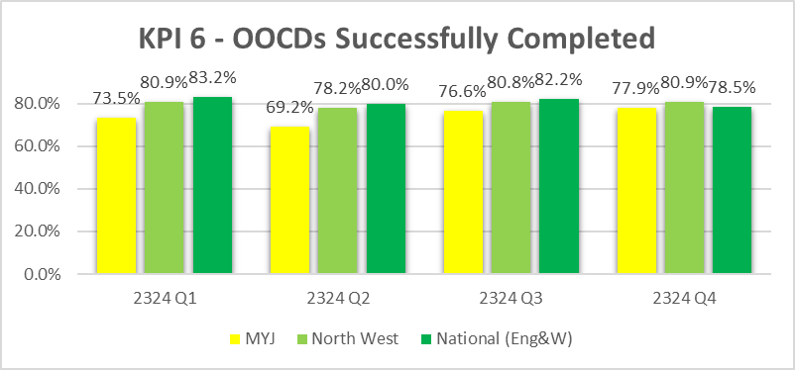

Between 1/4/2023-31/3/2024, 247 young people had a closed out of court disposal.

31 young people have offended further (12.6%). Most of the reoffending happened within 3 months of case closure (27 YPs/ 87%). The remaining 4 young people reoffended between 3-6 months post-closure.

The reoffending rate drops to 10.1% if they have Successfully Completed their intervention.
So a Young person who has Successfully Completed an out of court disposal is 3 times less likely to reoffend.

Turnaround Programme
Turnaround is a youth early intervention programme led by the Ministry of Justice
(MoJ). The programme provides grant funding to Youth Justice's (YJ) across
England and Wales currently until March 2025, enabling them to intervene earlier
and improve outcomes for children on the cusp of entering the Youth Justice
System. This additional funding has enabled extra support for children and families
who Youth Justice would not otherwise work with. Funding can be used in many
creative ways such as on community activities, vouchers for restaurants, shopping,
buying college or school equipment to name but a few examples.

Eligible children are those that have never been on a statutory Court Order, have
come to the attention of services through persistent ASB, released under
investigation by the police, discharged from Court, subject to an NFA decision or on
a first time Community Resolution or Youth Caution.

Outcomes:
- Between December 22 and October 24, across Manchester, 337 children were identified as being eligible (and suitable) for the Turnaround Programme either through the Out of Court process, overnight arrests, The Engage panel or acquitted at Court.
- 240 of these children proceeded to assessment and 231 fully engaged in this process, meaning that they proceeded to intervention and support.
- Of the 231 children proceeding to intervention, 184 successfully completed the Turnaround Programme.
- Of these 184, there have only been 9 cases of proven re-offending in the last 12 months. This equates to an impressive 4.9% re-offending rate which is evidence of how successful the programme has been in improving the outcomes of children and diversion away from the Youth Justice System.
- Of the 45 children who did not complete the intervention, there were varying reasons including declining support once intervention started, moving area, re-offending, opening to Early Help or becoming a Child Looked After.
- There are currently 47 children across Manchester actively receiving Turnaround intervention and referrals are being received on an almost daily basis, so it is anticipated that by March 2025 over 260 children will have successfully completed the programme.

Deferred Prosecution / Divert to Support Framework

In partnership with GMP’s Child Friendly Policing Lead’s Manchester Youth Justice have led a project to develop a pilot for a child first approach to deferred prosecution for children in Greater Manchester.

Child First practice is underpinned by 4 key principles :-

- Prioritise the best interests of children and recognising their particular needs, capacities, rights and potential. All work is child-focused, developmentally informed, acknowledges structural barriers and meets responsibilities towards children.
- Promote children’s individual strengths and capacities to develop their pro-social identity for sustainable desistance, leading to safer communities and fewer victims. All work is constructive and future-focused, built on supportive relationships that empower children to fulfil their potential and make positive contributions to society.
- Encourage children’s active participation, engagement and wider social inclusion. All work is a meaningful collaboration with children and their carers.
- Promote a childhood removed from the justice system, using pre-emptive prevention, diversion and minimal intervention. All work minimises criminogenic stigma from contact with the system.

What is Diversion?
Youth diversion schemes are a way of addressing certain criminal behaviours without putting children through the formal criminal justice processing (either through out of court disposals or prosecution) that can result in a criminal conviction and other negative consequences.

What is Outcome 22?
‘Outcome 22 is the Home Office outcome code, intended to reflect where a diversionary intervention has been used to result a case that does not meet the public interest test to take any further action. It is an informal outcome that results in an “no further action” (NFA), for use with both adult and youth cases.’

Outcome 22 can be used as alternative to formal OOCD or prosecution, where the evidential threshold is met. It is a non-statutory disposal, whereby the police have the option to put on hold a prosecution or caution until a diversionary activity undertaken.

Out of Court Resolution (OOCR) Pathway

- Offence committed, children are arrested, the evidential threshold is met and they are either taken into Police custody or is invited in for Voluntary Interview.
- For offences that are gravity 2/3/4 - OoCR Pathways should be considered
- If the arresting officer decision is to issue a first Community Resolution (CR) Disposal, YJ Police are notified after its issued
- If this is a second offence that could warrant a second CR, or the officer is considering issuing a Youth Caution the arresting officer will refer into the YJ OoCR pathway (Now to include Deferred Caution that can result in O22 disposal code if completed)
- Officer In Charge (OiC) has a consultation with their locality YJ Seconded Police Officer
- The OiC makes a referral to the YJ OoCR Joint Decision- Making Panel
- A Screening or Assessment is then completed, and recommendation made to the OiC on the suitable disposal and intervention.
- These include; Informal Outcomes- NFA codes, Deferred Caution (O22), Community Resolution, or formal outcomes Youth Caution and Youth Conditional Caution

Deffered Caution

Where the recommendation is deferred caution :-

- OIC must ensure that the victim is informed about the outcome and reasons why
- Assessment is completed by YJ, and an action plan is co-designed with the child and parent/carer
- Support can be for a duration: Up to 3 months for behavioural, cognitive, strength-based interventions
- A further 3 months of voluntary intervention can be offered for specialist interventions such as health, Speech and Language Therapy, Drama and Art Psychotherapy and AIM/HSB Interventions.
- Upon completion of the 3-month intervention the OiC/YJ Officer will authorise the Outcome 22 NFA code and close the crime
- Non-compliance to a satisfactory level, the OIC will be informed with a recommendation for the YJ Police Officer to issue a Youth Caution

Support and Protect: -
Oasis Navigator
The Navigator Project is a Youth Led Violence Reduction project commissioned by the Greater Manchester Violence Reduction Unit (VRU). The project launched in April 2021, and is operational within;

- Manchester Royal Infirmary
- Royal Manchester Children’s Hospital
- Salford Royal
- Royal Bolton Hospital

The aim of the project is to support young people presenting at the Emergency Departments with injuries caused by involvement in a violent incident. The project has now been expanded to include a pathway for community referrals (including primary care).

The project is open to any young person aged 10-25 years old that live or attend school in Greater Manchester that are impacted by youth violence.

The Navigators work with the young person to enable them to reflect and process their experiences following an incident. Navigators support children and young people to create their own bespoke support plan and when they are ready can identify local support networks, community groups and services that can support them long term to achieve their goals.

- Advocacy - schools, services, within statutory processes, families
- Crisis intervention
- Support with legal processes
- Confidence building
- Family support
- Employment, education, and training
- Listening
- Support to find accommodation
- Goal setting and raising aspirations
- Group work/One to One session

Oasis take part in the Engage panels on North, Central, and South of the city.

Evaluation Key Findings: Initial Implementation Pilot Evaluation December 2021 Manchester Metropolitan University:

- Navigators are positively viewed by staff in all 4 Emergency Departments
- They believe Navigators help improve Emergency Departments staff engagement with young people.
- Emergency Department staff would prefer to see an increased Navigator engagement in Emergency Departments with them on site more frequently
- Young people more likely to engage with Navigators than hospital staff building the trust necessary to progress positive interventions
- Communication about the programme with Emergency Department staff has been seen as vital to their engagement – due to turnover of hospital staff requires to be repeated/ongoing process
- Navigators spent more time and resource than initially envisaged in supporting clients who did not formally consent to intervention beyond Emergency Departments
- The longer term supporting and onwards referral role originally planned for Navigators has not been advanced for the majority of clients
- Data collection has had to be revised given chaotic lifestyles of Young People and time required to develop a trusting relationship

The Oasis Navigator project has also recently been further expanded to provide a parent and carer service providing one-to-one peer mentoring support to parents and carers who are concerned about their child’s behaviour.

The Children’s Society – Parenting Service
The service delivers intensive, therapeutic, trauma focused interventions with parents and carers to enable them to effectively safeguard children and young people and reduce/prevent further missing episodes. Support available includes :-

- Direct 1:1 sessions with parents around Missing From Home- these sessions can cover healthy communication, signs of exploitation, boundaries, parenting styles and the push/pull factors which cause children to go missing with a focus on reducing their child’s missing episodes. Sessions are bespoke and tailored to needs of each parent.
- Advice and guidance around missing for parent/carers who do not require intensive 1:1 support who have children who are going missing or have late curfews.
- Joint work between parent and child on practical role modelling, quality time/positive activities with your child, empowering the parent to understand the importance of time with a child.
- Outreach sessions in schools where YP have gone missing, with a focus on engaging and educating parents.
- Professional training around MFH and exploitation to be delivered to FC, residential workers and other professionals

Team around the School: The East Manchester Academy (TEMA)
Team around the School/Academy (TAS) is a multi-agency support which is triggered where a school is facing complex issues which may affect the school's normal functions. Manchester City Council began this strategy in 2019 and since then it has been introduced in other Local Authorities, including Salford.

In 2019 TEMA had an Ofsted inspection resulting in the school being judged to need special measures. Behaviour and community issues were cited as significant issues. A TAS was established following the inspection and stepped down in 2022 when it was agreed by the school and partners that it was no longer required.

The impact of the TAS was:

"Leaders have transformed the school into a place where pupils are happy and safe. Staff welcome pupils each morning with a warm smile and genuine care. Adults know pupils as individuals and provide them with high-quality pastoral support. Teachers are patient, calm and considerate of pupils’ needs. The East Manchester Academy (TEMA) is a beacon of hope and aspiration for pupils." Ofsted 2023
- Ofsted now judge safeguarding to be highly effective. "Leaders provide extensive wraparound care and support for pupils and their families."
- Student and parent voice consistently positive feedback
- Improved attendance and behaviour
- Long term reduction of exclusions, particularly for vulnerable and SEND students
- School has developed a whole school system and ethos for supporting mental health and wellbeing of students and has provision of mental health professional in school for students
- School has become a best practice example of Early Help at secondary school

Rock Up
Rock Up works with the youth justice service, offering high quality and creative music making activities. It is a responsive and flexible programme that meets the needs and interests of the young people, supporting them in their own personal journeys and inspires them to access mainstream and creative provision opportunities. It includes weekly musician in residence workshops and intensive creative music weeks. As part of the Rock Up programme Theatre in Probation and Prisons (TiPP) is supporting Manchester Youth Justice’s ambition to become an arts-based service.

Unity Radio
Unity Radio is a series of workshops for young people designing, developing and delivering live radio shows broadcast on Unity Radio. The content of each radio show contains features and discussions between young people, reflective workshops, with critical discussion, educating young people about enhancing their safety, preventing violent crime, and challenging the attitudes that enable violence. This preventative education is focused on promoting positive attitudes around young people their own age, recognising patterns and vulnerabilities that might lead to violent crime, criminal activity, healthy relationships, sexual citizenship and consent, as well as peer schemes, advocates, and role models.

Disrupt Divert and Enforce
Another Chance

Another Chance is a Youth Endowment Funded project that seeks to build evidence on a focused deterrence approach that has seen some success in the US. The project will take place across the City of Manchester and a defined area of North Trafford until December 2025.

The Another Chance Steering Group comprises partners from GMCA, GMP, MCC, Education, Health, Probation, Fire Services, Lived Experience, DWP and Youth Justice. They have supported the programme through committed resources that have helped shape the design of the fundamental elements needed to enable progression to delivery stage.

As an innovative approach for Manchester, it has been critical to have partner oversight and challenge of the proposed delivery model to minimise risk to our cohort. For example, partners have shared details of the services available and routes of access for our cohort. They have also ensured that our model uses child-centred policing policies, and that processes include measures that are proportionate to the cohort by taking into account whether they are under or over 18.

The programme targets 14-25 years olds who have been identified through Police data as having been involved in serious youth violence such as knife crime, burglary, sexual assault etc. within a group dynamic (two or more people) within the last 24 months. Through our delivery partner, the cohort are offered the opportunity to work with a mentor to identify support and services that meet their needs and will help them turn their lives around.

If those identified as part of this project continue to commit criminal offences, then consideration will be given to utilising enforcement powers to address behaviour. Such powers may include (but are not limited to); Policing powers, Youth Justice powers and civil enforcement tools and powers.

SHIFT

SHiFT Manchester launched in October 2023 based within Manchester Youth Justice. The project is currently in the initial mobilisation phase with a view to identifying 23 children and young people to support by the end of November 2023.

The practice has a particular focus on reducing the use of custody for children and an interest in improving outcomes in this area by preventing the need for custodial remands and sentences through intensive levels of community support and improving resettlement outcomes as young people transition from custody to the community, reducing the need for recall. The practice will work alongside some of the most vulnerable children from across the city to break the destructive cycle of crime and influence system change, with a particular focus on challenging disproportionality.

Projected cost savings year 1:-

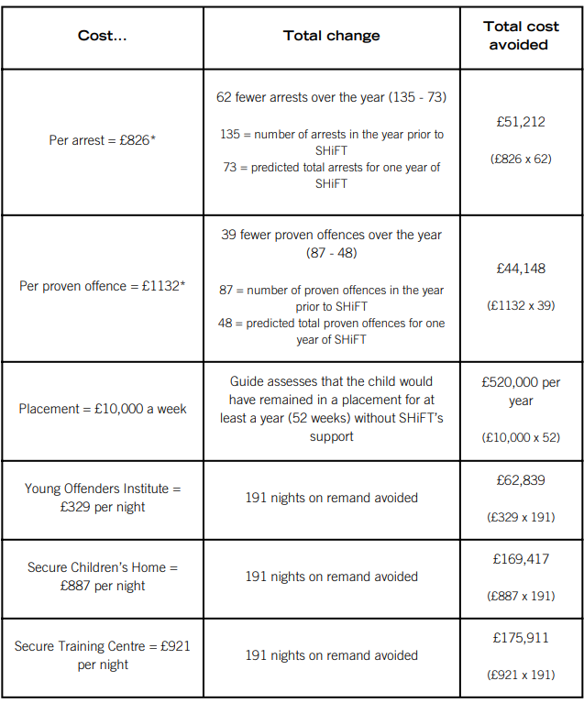

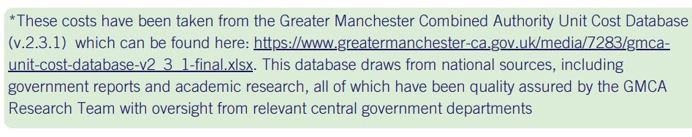
GMP Policing Operations -
There are currently several ongoing GMP operations which contribute to the reduction of serious violence across the city. A couple of examples are outlined below: -

- Op Cura - Operation Cura is a partnership approach between GMP and educational establishments to tackle youth-based violence, exploitation, and victimisation in Manchester City Centre. Operation Cura establishes a notification requirement, like Operation Encompass, creating a referral mechanism to schools/colleges the next day. By identifying those children at risk of exploitation or on the periphery of crime and notifying the relevant schools / colleges the following day so that any concerns, support or welfare needs can be addressed early, and a successful intervention can be put in place to reduce risk to vulnerable people and stop people becoming victims in the first place.
- Op Venture – The Operation Venture team compliments the work of the VRU and is comprised of full-time officers who are ringfenced to patrol serious violent crime hotspots across Greater Manchester. The teamwork with districts to keep communities safe and utilise tactics such as: weapons sweeps, proactive patrols, intelligence led stop & search, community engagement & referrals to divert people away from violence. The team have been formed twelve months and have affected 345 arrests, 342 positive stop searches, seized 88 weapons and bladed articles and conducted 144 referrals to partnership agencies
- Operation Vulcan Piccadilly - Following this success, GMP and partners are working to bring the same dynamic change, vigour and enthusiasm to Piccadilly Gardens. Using the same specialist taskforce, alongside local neighbourhood officers and PCSO’s, dedicated resources will be embedded into Piccadilly Gardens to identify the root causes of the existing problems and work closely with local residents and partners to eliminate the criminality in all its forms, helping to create a safer community and supporting businesses to thrive and grow. Policing alone will not solve these problems, and that is why the multi-agency approach is so key to tackle the issues in Piccadilly Gardens. Working with Manchester City Council, Greater Manchester Combined Authority, Home Office Immigration Enforcement, and local businesses and charities, this is our commitment to tackling and creating sustainable resolutions to issues such as anti-social behaviour, drug dealing, exploitation, theft from person, and violent crime which have, for too long, impacted the lives and livelihoods of those in and around Piccadilly Gardens.
- Op Custodian - Operation Custodian is GMP’s weekly response to policing the NTE on a Friday and Saturday night in Manchester City Centre. Over the course of the weekend over 200 incidents are reported to GMP. An additional 40 officers are designated to this this operation per evening working between the hours of 10pm to 7am. The operation consists of our response to incoming demand, high visibility foot patrols to prevent and reassure and our pro-active capability in helping keep people safe in the city centre. Alongside specialist licensing officers our operation is supported by partners and volunteers including the Village Street Angels. Our patrols are designated to areas which generate the highest demand and footfall in the nighttime economy. Alongside our Custodian operation we run operation Mantle – our response to VAWG in the nighttime economy as well as operation Sycamore – a pro-active plain clothes operation focused on hotspots for violent crime.

The work ongoing in the above GMP operations in relation to the reduction of serious violence is further complemented by other enforcement activities undertaken by Manchester City Council’s Community Safety, Compliance and Enforcement Services. Some of these activities include: -

- City Centre Public Space Protection Order – One of the widely accepted drivers of serious violence relates to the consumption of alcohol. There is currently a city centre Public Space Protection Order (PSPO) in place across Manchester city centre which prohibits the consumption of alcohol in any public place (other than licensed promises). Officers from Anti Social Behaviour Action Team (ASBAT) and the Licensing Team conduct joint operations with GMP in hotspot areas to raise awareness of the PSPO, offer support to those breaching the PSPO and consider enforcement action in cases of non-compliance.
- Criminal Behaviour Orders – ASBAT work closely with various GMP teams to secure Criminal Behaviour Orders against the most persistent and serious offenders to deter them from engaging in further offending and antisocial behaviour across the city. If granted, orders can include exclusions from hotspot areas, non-associations and positive requirements which are aimed at compelling individuals to engage with support to address the underlying factors of offending behaviour.

Summary of Projects and Evaluations
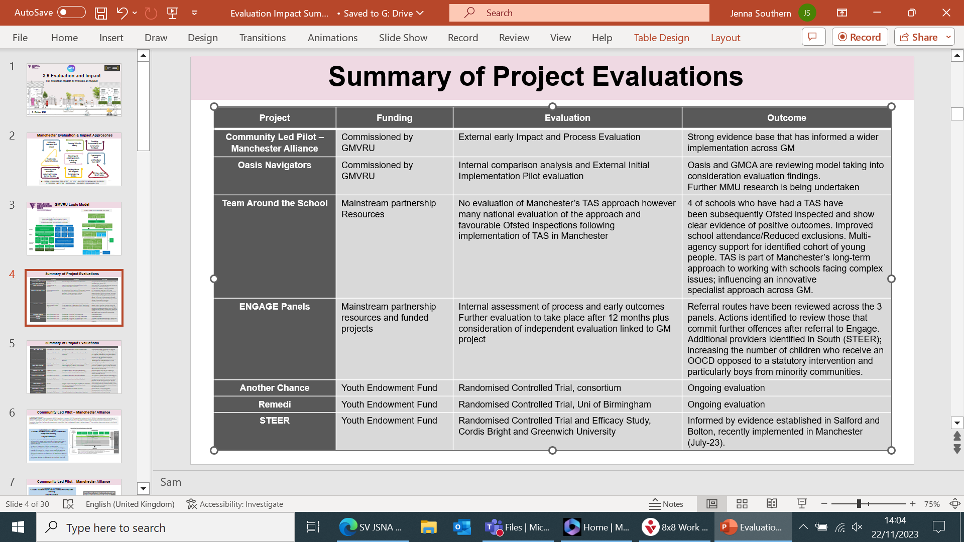
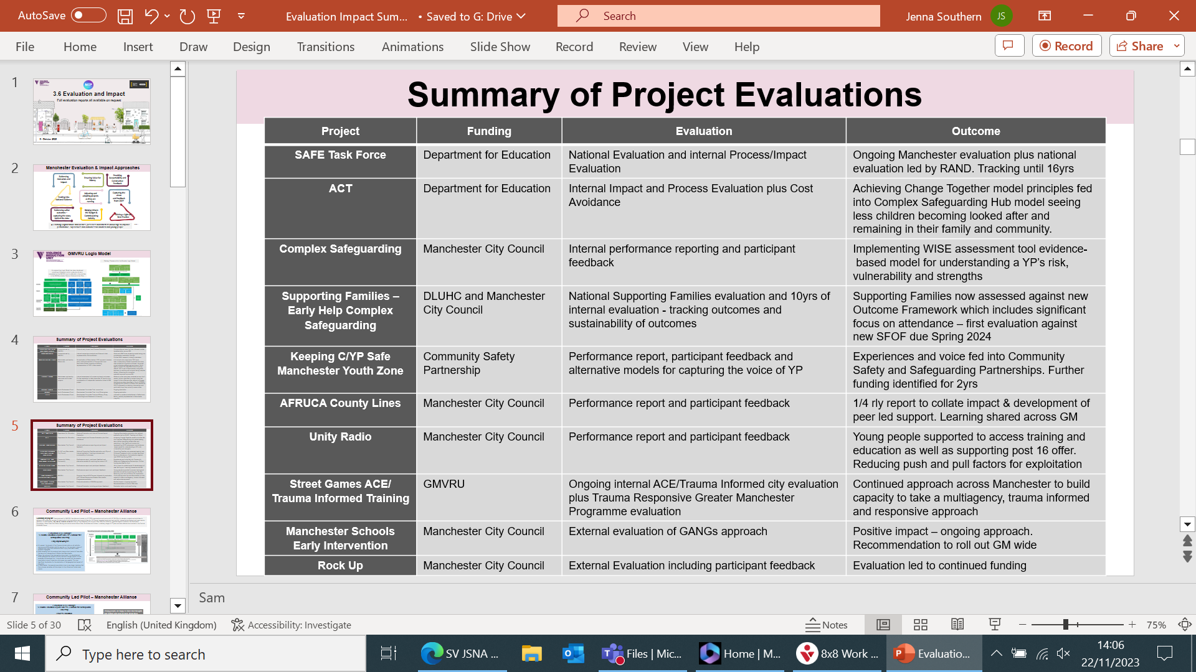

6. OPPORTUNITIES FOR ACTION
6.1 Opportunities to better address this issue

The biggest opportunity, but also the biggest challenge, is one we have been highlighting for at least the past two years, and is where, if we are truly to ‘deliver differently’, we need to come together and pool resources for the long term good.

While there is much high quality and committed work being carried out by statutory services and our excellent local voluntary and community sector providers, the vast majority of it is reactive.

This assessment reaffirms what has been reported in the last two Strategic Threat Assessments and in numerous other bespoke data capture exercises. The serious violence picture in Manchester is complex and is made up of several different issues, including young people, young adults, domestic abuse, the street community and the nighttime economy all being factors in the increases in the number of serious violent and homicide.

The Serious violence Board is aware of the need to develop work in the following areas: -

Whole family approach -

Manchester communities have been clear that through our response to serious violence it is not only key to offer support to individuals, but also to their families. We know that families play a key role as a protective factor throughout the course, from pregnancy right through to adulthood. As a partnership we have developed our response to taking a whole family approach through developing our commissioned services to provide whole family support including the following: -

- Early Help
- Afruca
- Manchester Youth Zone
- Oasis Navigators

Due to the acknowledgement that this is an area we need to continue to develop the principle relating to “Think Family” will continue to remain a priority of the Serious Violence Strategy.

Children and young people involved in serious violence

Our research and data analysis indicates that children and young people account for between 12% and 14% of serious violence in Manchester (as perpetrators). However, what we have also identified is that there is a cohort of young people who are responsible for a high proportion of the 12%-14% (also could be described as a high rate of repeat offenders within this percentage).

The introduction of Engage sought to provide early intervention and prevention for children not known to services. However referrals are being received for children that are known to statutory services. We need to ensure that those children involved in serious violence that are known to services like Children’s Social Care are also accessing the support they need from those services, rather than accessing services designed for early intervention and prevention.

From various research, deep dives and reviews, we also know that some children and young people known to statutory services such as Youth Justice and Children’s Services (complex safeguarding), despite the efforts of professional engagement, risk management with these young people can be challenging.

There is a need for us to develop how we work with children and young people who are involved in serious violence, present escalating behaviours, pose heightened risk (to themselves and others) and who are not engaging with support. Through working with partners across the city, Manchester is in the early mobilisation phases of two programmes of work, SHIFT Manchester and Another Chance, as alternative means of engagement with children and young people who are repeatedly involved is serious violence (details in section 5.2).

There will be independent analysis and evaluation of both programmes on an ongoing basis to understand their impact on this cohort of children and young people.

Transitions

Through mapping activity undertaken in last year's Strategic Needs Assessment it was identified that there was a lack of support services available across the city for children and young people transitioning into adulthood.

Through the analysis of data, we see that “at risk age groups” linked to serious violence offences continue beyond the age of 18 years, when many services stop offering support. This is an area for continual development across the partnership and will remain a focus for the Serious Violence Board.

Evaluations
Given the commitment in Manchester to a Public Health Approach to serious violence reeducation there needs to be a strong focus on our interventions being rooted in evidence.

There has been extensive growth in relation to our interventions across the city in the last 12 months, especially in the space of early intervention and prevention. It's essential to understand the impact of these approaches to assess “what works” and consider the best use of our available resources. Although a full evaluation of many of the projects is not available due to them being in their infancy, ongoing reviews are undertaken to identify early indications to influence our direction of travel.

Evaluations that are available are referenced in the table at page 54 Evaluation of interventions to allow us to understand “what works” will be overseen and implemented through the Serious Violence Board.

6.3 Implementing learning from reviews

The Serious Violence Board is committed to continually reviewing the practice of individual agencies and the partnership. It is essential that we continue to commission reviews to better strengthen our knowledge and practice to ensure we improve practice to protect and support those at risk of being drawn into serious violence.

Joint Targeted Area Inspection (JTAI)

In September / October 2023 Manchester underwent a JTAI in relation to Serious Youth Violence. The inspection was led by Ofsted and involved a total of 12 inspectors from Care Quality Commission, Ofsted (schools and social care), His Majesty's Prisons Inspectorate and His Majesty’s Inspectorate Constabulary Fire Rescue Services.

The scope of the inspection considered 3 broad areas.

- Strategic Partnership responses to serious youth violence (how well do partners work together, understand and respond to issues in Manchester)
- Intervention with individual and groups of children affected by serious youth violence and criminal exploitation (how do partners provide timely, purposeful and impact positively into children and their family’s lives)
- Intervention in places and spaces (contextual safeguarding and how partners use intelligence to inform activity and disrupt)

The strengths identified in the inspection were:
- Robust multi-agency arrangements with clear accountabilities and a well understood strategy are leading to many children receiving a range of effective responses to address serious youth violence.
- A significant number of innovative approaches and interventions developed and managed by the partnership are making a positive difference to children’s lives.
- A culture of professional challenge and shared learning is helping to enable improvements in practice and in the impact of services.
- The views and aspirations of children are generally well understood. Professionals are developing a progressively more accurate, shared understanding of children’s lives and of the effect on them of experiencing serious violence and exploitation.
- A consistently strong approach to building relationships with children is supporting effective interventions to reduce risk.
- Most partner agencies have a good understanding of the range of risks from serious youth violence and criminal exploitation faced by children, and this enables them to offer a range of appropriate support aimed at reducing risks.
- An effective approach is in place for prevention and early intervention, and to support the engagement of schools. There is an increasingly good mentoring offer that is making a positive difference for children.
- The CSH delivers strong multi-agency working that, overall, provides effective expertise, advice, help and intervention for children at significant risk of serious youth violence and exploitation.

The areas for improvement were identified as:
- How effectively the arrangements for the monitoring and evaluation of serious youth violence support the partnership in implementing its strategy.
- How well the strong strategic intent to address the disproportionate impact of serious youth violence and criminal exploitation on children from some ethnic backgrounds and those with special educational needs and/or disabilities (SEND) has been translated into positive change for children.
- The specificity and thoroughness of plans, and how effectively they are implemented, reviewed and developed so that children get the right help at the right time.
- How consistently professionals look beyond the needs of an individual child, for whose safety or welfare there may be concerns, and consider risks to the wider group of children, such as brothers, sisters and peers associated with that child.
- The consistency with which key information is recorded and shared between partners to enable effective decision-making.
- The awareness of professionals about the range of services that are on offer to support the emotional well-being and mental health of children at risk from serious youth violence or criminal exploitation, as well as waiting times to receive therapeutic treatment as part of the core child and adolescent mental health services (CAMHS)

An action plan has now been developed to address the areas for improvement:

Manchester JTAI Serious Violence Action Plan
(Updated - November 2024)
Ref | What needs to improve/ACTION | What will the impact be and how will we know | Evidence of progress | Lead Agency/Officer and Timescale for completion (*end of respective month) | Update
1. How effectively the arrangements for the monitoring and evaluation of serious violence support the partnership in implementing its strategy.
1.1 | Develop an evaluation framework that includes feedback from young people and scorecard to monitor the progress and impact of the Serious Violence Strategy. | Informed decision making through a dynamic response to serious violence that measures both experience and outcomes for children affected. | Clear performance and assurance arrangements to measure progress against key milestones and impact of Serious Violence Strategy | Sam Stabler - Community Safety Partnership (CSP) via the Multi-Agency Serious Violence Board, and Greater Manchester Violence Reduction Unit | Draft framework shared at SV Board April 24. Health measures have been added and revised draft shared with PRI.
 |  |  |  | May-24
1.2 | Ensure that evaluation of effectiveness is incorporated within routine interactions with CYP across the Partnership, using engagement mechanisms such as the Youth Participation Framework | The views of CYP Children and Young People) inform evaluation of contacts/interventions that services have with them which will drive up effectiveness of work to support them in achieving outcomes. | Young people’s views/feedback are routinely used alongside performance reporting. | All agencies with the Community Safety Partnership. | Evaluation framework built in to SV Board agenda. Schedule of youth voice identified for SV Board meetings.
 |  |  |  | (Assured by the MSP)
 |  |  |  | Apr-24
1.3 | Increase use of Youth Participatory models of engagement with young people | The voices of children/young people whose voices are less well heard will be amplified and involved in decision making and are confident self-advocates. | Agencies can provide examples of how a youth participatory approach is embedded in practice. | All agencies with the CSP | Child friendly city plan has been agreed and includes actions across the partnership to improve engagement. Youth voice and participation included in commissioned projects and programme of youth voice agreed for SV Board.
 |  |  |  | Apr-24
2. How well the strong strategic intent to address the disproportionate impact of serious violence and criminal exploitation on children from some ethnic backgrounds and those with special educational needs and/or disabilities (SEND) has been translated into positive change for children.
2.1 | EHCP are used to inform multi agency child in need, child protection or my safety plan, and clearly identify the vulnerability, education and health need to be addressed in the plan | Partners will collaborate effectively so that any barriers are removed in order that CYP are supported in attending school and achieving expected outcomes, including progression to Education, Employment or Training at post-16. This includes children with identified SEND needs, those with an EHCP and children who may be affected by disproportionality. | For all children known to Children’s social care with issues regarding Serious Violence who have an EHCP, there is evidence that the plan identifies the child’s specific need and vulnerability to the risk of serious violence and this is incorporated in the child in need, child protection or my safety plan | Education/Manchester ADQ/Health/CSC | Children's Services planning improvements including assessments plans and meetings developed into training programme rolling out from May 2024. CIN and CP updated to include Safety Planning. QAF also updated onto plans and CSG in all three localities.
2.1 | (See also Action 3.1) |  | Audit conducted by Complex Safeguarding Team | May-24
2.1 |  |  |  | Complex Safeguarding Team/MSP SEG
2.1 |  |  |  | Jun-24
Cross Ref Action | See also Action 3.1 (Review practice/operational guidance)
2.2 | Evaluate the current data and audit of 100 children’s experiences and develop a regular cycle. | A continually deepening understanding of the experiences of children from global majority communities to continually inform practice and strategic planning. | Initial results will provide a baseline against which progress and impact can be measured. | Community Safety Partnership | DPIA completed and signed off April 24 to enable baseline data. Initial data collection commenced with baseline data expected by September 2024.
 |  |  |  | Feb 2024 and annually thereafter
2.3 | Child Centred Policing Strategy and Manchester Plan to have a cross-cutting regard to children’s cultural, religious and ethnic identity. | It is expected there will be a reduction in the over-representation of black and mixed heritage within the criminal justice system. | Regular reporting and assurance arrangements via Manchester’s governance arrangements (CSP and MSP). | Sara Harris , Superintendent GMP | Child Centred Policing Strategy action plan in place
 |  |  |  | (Dates as in CCPS) | Child Centred Policing Strategy action plan in place
2.4 | MSP to commission training for multi agencies partners on culturally competent safeguarding children and adults practice. An expectation of this training will be that partners would implement learning into their own agencies | An increase in knowledge, skills and abilities of staff across the partnership and city. | Impact Survey completed to evaluate effective of training in improving agency practice | Ruth Speight, Co Chair, MSP Learning & Improvement Group | Training provider identified. Training content yet to be agreed.
2.4 |  |  | MSP Section 11 audit includes a standard to demonstrate cultural competency practice | Training commissioned
2.4 |  |  |  | Feb-24
2.4 |  |  |  | Training included on training offer calendar
2.4 |  |  |  | Apr-24
3. The specificity and thoroughness of plans, and how effectively they are implemented, reviewed and developed, so that children get the right help at the right time.
3.1 | Children's services, along with relevant partners, to review practice and operational guidance that supports specificity and thoroughness of plans for children. | Greater consistency in planning with children and their families including the needs of brothers/sisters and contribution of all agencies and decision making using the QAF, sampling and supervision | Routine reporting arrangements within CSC. | Sean McKendrick/Relevant partners from Health, GMP, Education | Paul Allen's programme of change rolling out from May 24 as 2.1
Cross Ref Action | See also Action 2.1 (EHCPs)
4. How consistently professionals look beyond the needs of an individual child, for whose safety or welfare there may be concerns, and consider risks to the wider group of children, such as brothers, sisters and peers associated with that child
Cross Ref Action | See Action 3.1 (Review practice/operational guidance)
5. The consistency with which key information is recorded and shared between partners to enable effective decision-making
Cross Ref Action | See Action 3.1 (Review practice/operational guidance)
5.1 | All agencies to ensure that their information sharing practices meets the requirements of the MSP Information Sharing Protocol. | Information is shared appropriately between partners where there are safeguarding concerns and throughout support provided to a child, young person or family | Agencies to take any actions (e.g. dissemination of protocol, advice to managers/practitioners) that ensure staff are aware of and comfortable with using the Protocol in practice. | MSP | The information protocol has now been signed off at the relevant executives.
5.1 | MSP Information Sharing Agreement is shared across the partnership through the L&I subgroup for discussion at multi agency safeguarding forum and implementation across agencies. |  | MSP Safeguarding Fora minutes to reflect multi agency review of MSP Information Sharing Agreement discussions | (Via Executives and L&I subgroup)
5.1 |  |  | MSP Section 11 audit to evaluate application of MSP Information Sharing Agreement | Feb-24
5.1 |  |  |  | L&I subgroup
5.1 |  |  |  | Jan-24
5.1 |  |  |  | Annual Audit
5.1 |  |  |  | (via Safeguarding Executive Group)
5.1 |  |  |  | Jan-24
6. The awareness of professionals about the range of services that are on offer to support the emotional well-being and mental health of children at risk from serious violence or criminal exploitation, as well as waiting times to receive therapeutic treatment as part of the core child and adolescent mental health services (CAMHS)
6.1 | 7 Minute Briefing (MB) is produced and shared across Partnership about what is on offer around serious violence | There is increased awareness across the partnership and practitioners and managers have a clearer view of what is out there/available, knowledge and awareness. | 7 MB is produced and shared across the partnership | Jenna Southern CST and Callum Dibbert MSP | Draft briefing developed, to be shared with SV Board. Feedback from Board obtained and shared back to MSP to finalise.
 |  |  |  | Feb-24
6.2 | In areas where clarification may increase understanding, communication is produced and shared across the partnership setting out | Agencies and practitioners working with CYP at risk from serious violence or criminal exploitation and who need support with well-being and mental health have a clear understanding of expectations, referral times and processes, pathways and outcomes. | Health, GMP (and any others identified where clarification would be helpful) produce and disseminate clear, concise guidance which is shared across partnership via the MSP Information Bulletin. | Manchester ADQ/Health, GMP | MFT Communications Team are supporting CAMHS with the publicity arrangements for launching the updated CAMHS offer. CAMHS now have a representative on the MFT Complex Safeguarding subgroup who will provide quarterly updates of their progress
6.2 | • CAMHS – capacity, clinical pathways and timescales. (Health) (See also Action 6.3) |  |  | Feb-24
6.2 | • Engage (GMP) |  | Awareness, Impact and understanding will be tested via MSP s11 audit process.
6.2 | • Thrive (Health)
6.2 | • Risks and services available for girls (CSC)
6.2 |  |  |  | MSP annual report 2024/25
6.3 | Child and Adolescent Mental Health Service (CAMHS) will develop a communication strategy and deliver a communication campaign inc timescales for referrals and response, with development Jan – Mar 2024 and delivery from April and ongoing, | There is increased awareness across the partnership and practitioners and managers have a clearer view of what is out there/available, knowledge and awareness. | Communication strategy developed and delivered | Al Ford Director of CAMHS | Deputy Director CAMHS has reported that due to the expansion of their services, partners have raised the difficulty of knowing when and where to refer young people to CAMHS. There is currently work progressing to make this a clearer process for partners. CAMHS are looking at their front door model and whether this needs to change.
 |  |  |  | Manchester University NHS Foundation Trust (MFT)
 |  |  |  | Strategy developed
 |  |  |  | Mar-24
 |  |  |  | Strategy communicated/delivered from:
 |  |  |  | Apr-24
6.4 | Develop a pilot project to enable Neurodevelopmental Risk stratification - prioritizing vulnerable groups e.g., young people connected to the Youth Justice system. | Prioritization of vulnerable groups to receive therapeutic treatment as part of the child and adolescent mental health services (CAMHS) | Neurodevelopmental Risk stratification priorities vulnerable groups | Al Ford Director of CAMHS | Deputy Director CAMHS has reported an overrepresentation in young people in the Youth Justice team who may have neurodiverse needs (e.g., ASD and ADHD), the prioritisation of vulnerable groups is now being piloted in Manchester CAMHS, which includes young people at risk of serious violence. CAMHS are in the process of publishing both a high level and then service specific waiting well offers.
 |  |  |  | Manchester University NHS Foundation Trust (MFT)
 |  |  |  | Pilot developed
 |  |  |  | Apr-24
 |  |  |  | Roll out/Offer Launch, starting:
 |  |  |  | Apr-24
6.5 | Develop a waiting well (while you wait) offer for children and young people awaiting a CAMHS appointment. | Additional service offer whilst children and young people await CAMHS appointment | Additional support offer is provided whilst children and young people wait for core offer | Al Ford Director of CAMHS | CAMHS have met with MFT Communications Team and the waiting well offer is published on the MFT intranet site at Child and Adolescent Mental Health Service (CAMHS) - Royal Manchester Children's Hospital (mft.nhs.uk)
 |  |  |  | Manchester University NHS Foundation Trust (MFT)
 |  |  |  | Apr-24

6.2 What should local partners be doing to take advantage?

Improving the range of data regularly made available on inward traffic, outputs and outcomes.

Exploiting opportunities for local partnership working and problem solving

As described in sections 5.1 and 5.2, there has been much promising work over the past two years in localities to collectively address the issues and challenges presented to agencies by people with complex needs and vulnerabilities. While these local partnership arrangements require investment by partners in the process and the joint working, the outcomes can be beneficial to all agencies in terms of long-term demand reduction, and to the people who are the subject of these interventions in terms of improvement to their quality of life and prospects.

6.3 What can external partners do to help us?

The chief external partner with the greatest influence on our local activity, and the opportunity to help us enhance it, is of course the Government. The pandemic, and their response to it in regard to serious violence issues, has highlighted some long-standing issues that need to be addressed centrally in order that the task of local partners is made easier.

Two of those issues are sufficient and sustainable funding, and communication between Government departments on an issue that cuts across most of their remits.

Cross-government communication – Serious violence is an issue that cuts across the remits of those in charge of children’s and adults social care, health, housing, education and policing / criminal justice services.

At a local level this is largely understood, and considerable effort continues to be made to promote and implement integrated, joined-up responses.

At a national level, however, there is a way to go. The pandemic, and Government’s response reminded us of this, with local authorities and partners being separately in receipt of information and opportunities to bid for funding to address aspects of the agenda almost simultaneously from different Government departments.

Inter sector communication – The VCSE have additional capabilities to apply for funding streams that statutory services cannot access and vice versa. There needs to be improved communication when developing bids or services to meet the needs of victims and perpetrators and to ensure that new projects fit with the priorities of the Serious Violence Strategy. This will prevent duplication and improve pathways to support and provision across the city

7 REFERENCES AND LINKS
- State of the City report 2020 (Manchester City Council PRI team)
- Community Safety Partnership quarterly data reports, 2020-21
- Community Safety Partnership Strategic Threat Assessment 2024
- TIIG (Trauma & Injury Intelligence Group) report 2023-24
- Youth Justice Peer Review November 2021
- Manchester Trafford child safeguarding practice Review 2022
- DFE / MOJ doc

In addition to these linked reports and strategies, this needs assessment has been the product of numerous bespoke reports and data capture exercises by colleagues in agencies and services across the city. These have included:

- MCC Early Help Service
- Manchester Children’s services (including complex safeguarding)
- Manchester Health and Care Commissioning (MHCC)
- Greater Manchester Police
- Manchester Youth Justice
- Manchester Probation
- Department for Education / Manchester’s City Council Education Departments
- Greater Manchester Fire and Rescue Service
- Manchester Voluntary and Community Sector partners

I would wish to put on record my thanks to colleagues in all of these agencies and services who have taken the time to produce and submit information, whilst carrying out their work in challenging day-to-day circumstances.

Completed by: Jenna Southern - Serious Violence Manager
Date: 31.1.25

Homicide, attempt murder, grievous bodily harm with intent.
Lower Super Output Areas

