Former Boddingtons Brewery Site
STRATEGIC REGENERATION FRAMEWORK
ADDENDUM

June 2019

Contents

Executive Summary 1
1.0 Introduction 2
2.0 Policy Context 3
3.0 The Site 4
4.0 Development Proposals 6
5.0 Design Principles 8
6.0 Delivery and Phasing 13

Appendix A: Related Policy Objectives

Executive Summary
This document provides an addendum to the site development framework for the former Boddingtons Brewery site to the north of Manchester City Centre. The Boddingtons Development Framework was approved by the City Council Executive in 2015. This document relates to proposals for the western part of the former Boddingtons site. It is not a comprehensive revision of that document and so is presented as an addendum to the 2015 document

Since the 2015 Framework, a planning application has come forward for residential development on the eastern part of the Boddingtons site. The Council is minded to approve this application, subject to the signing of a section 106 agreement.

This addendum addresses the opportunity that has arisen for the Manchester College to build its new city centre campus on the site. It promotes educational use on the western part of the site, principally to form a new city centre campus for The Manchester College - the largest provider of further education and vocational training in Greater Manchester as well as a significant provider of higher education. The campus forms a critical part of the College’s estate strategy and will make an essential contribution to the delivery of the skills strategy for the city and the city region. The College took legal ownership of the majority of the western part of the site in February 2019.

The College has not taken ownership of that part of the overall site that was identified for a multi-storey car park in the 2015 document. The original Framework provisions for the car park remain.

The College has plans for a multi-phase campus development. If later phases are not pursued, there will be opportunity for alternative uses to come forward on part of the western area of the site. Uses could include residential, hotel or commercial uses.

With a phased approach to development expected, the College may promote temporary uses on part of the site, including a continuation of the current car parking uses. There is also potential for “pop up” or other temporary uses.

The Framework supports the provision of high quality public open space and public realm, consistent with the existing framework. It also recognises that the College campus will be an important community resource and will welcome local people to its theatres, restaurant and other venues and activities.

The provision of the 2015 Framework remain in supporting a comprehensive approach to the whole of the former Boddingtons site, with a high quality of public realm and a single coordinated approach to estate management.

The Boddingtons development opportunity will contribute to the creation of a high quality, mixed use and vibrant new northward extension of Manchester City Centre. It will deliver high quality residential development and enable an educational campus critical to the long term needs of the city and city region economy. As a gateway site, the uses, form and quality of development will also support the delivery of the aspirations for land to the north, as outlined in the Great Ducie Street Regeneration Framework (which was approved by the Council in 2018).

This addendum to the Framework is the final version and was approved by the Council’s Executive at its 26 June 2019 meeting. This follows a draft document which was subject to public consultation.

Introduction

This document is an addendum to the site development framework for part of the former Boddingtons Brewery site on the northern edge of Manchester City Centre.

Previous Strategic Regeneration Frameworks (SRFs) have been prepared for the whole former Brewery site in 2007 and in 2015. Since the 2015 Framework was approved by the Council, a planning application (submitted by Prosperity) has been supported on an eastern portion of the site for 556 residential units and for 3490 sq.. m of commercial floorspace.

The majority of the remaining, western part of the site has been purchased by The Manchester College (LTE Group). The exception is that the College is not buying the site identified in the 2015 Framework for a multi-storey car park (MSCP) and is not acquiring the land identified for extensive public realm, linking to Trinity Way, that formed part of Prosperity’s recent planning application.

The College proposes to build a new city centre campus on the site. The campus will be built in phases, subject to demand and subject (in part) to public sector funding support and business case. If the College does not require all of the land being acquired, alternative uses may be brought forward.

This addendum to the site development framework presents the rationale and case for the new College and sets out the development principles that will impact the development on the College site. The approach is consistent with the principles of the 2015 Framework. The provisions of that Framework remain valid.

Policy Context

The 2015 SRF contained a detailed discussion of the planning and other economic and development policies that were relevant at the time. The addendum is consistent with the previous and adopted planning policies and policies to support the economic development and wider policy objectives of the Council.

In addition, the construction of the College campus on the site contributes to:
- The Greater Manchester (GM) Work and Skills Strategy
- The College’s Estate Strategy 2017-2022 (which was endorsed by the Council in 2017)
- The aims of these strategies are further detailed at Appendix A below.

The College’s estate strategy will bring major economic and community benefits to the City and Greater Manchester. The education and skills benefits are the driver for the estate strategy and will support delivery of the objectives and targets of the GM Skills Strategy.

Within the College’s strategy, around £100 million of construction expenditure will create some 500 construction jobs and provide training and apprenticeship opportunities. The College will deliver programmes to support these opportunities which will be targeted at Manchester residents.

Release of surplus sites would provide land for around over 700 new dwellings, much needed in the city and with a range of values and tenures; as well as potential to provide office, hotel and other uses.

Surplus sites will also provide opportunities for community infrastructure including new school places and enhanced sports facilities.

The Appendix of policy documents also references the Great Ducie Street Strategic Regeneration Framework, approved by the Council in 2018 and which relates to an area of land immediately adjacent to the former Boddingtons and running further north from the site.

The Site

a) Ownership

The College has acquired the western part of the site on a part leasehold and part freehold basis. Some freehold interests remain with the City Council and there are some small title interests with third parties.

The eastern part of the site is subject to an agreement between Realty Estates/Deansgate Securities and Prosperity.

A plot of land fronting Francis Street and “strip” of land between this plot and the Inner Ring Road has been retained by Realty Estates/Deansgate Securities.

b) Area

The total area of the former Boddingtons’ Brewery site extends to some 2.75 hectares.

With recent property transactions, the extent of ownership is now as follows:
- College 1.36 hectares
- Prosperity 1.13 hectares
- Deansgate Securities 0.26 hectares.

c) Current use

The majority of the site is currently used for surface car parking. Planning permission exists for temporary use. For the eastern part, the temporary permission lapses in May 2019. For the western part it lapses on 21 August 2019.

d) Accessibility

The site has excellent public transport links being walking distance from Victoria Station with mainline rail and Metrolink services. The Shudehill bus and tram interchange is also within walking distance. There are good bus connections, including stops along Great Ducie Street. Proximity to the Inner Ring Road provides excellent road connectivity.

Any development will need to provide a high-quality pedestrian environment and have regard to pedestrian safety issues related to the crossing of the Inner Ring Road.

e) Environmental Considerations

Development of the site will need to have regard to issues of air quality given the frontage to the Inner Ring Road.

There is scope to provide high quality public realm to provide a link between the city centre and the area to the north, where new development is promoted via the Great Ducie Street Regeneration Framework.

The topography of the whole former Boddingtons site is challenging due to eastern part of the site being at a higher level. It is this part that is subject to proposal for new residential development. The remainder of the site is more straightforward to develop, although there remain level differences to address on the Inner Ring Road frontage with a drop in levels from east to west.

f) Opportunities and Constraints

It follows that the site presents a number of opportunities as a strategic development site on the fringe of a rapidly expanding regional centre.

It should provide a high-quality environment and public realm and act as a gateway site to further development areas to the north (as promoted through the Great Ducie Street Regeneration Framework).

There is an opportunity to deliver a world class educational facility to serve the further education and vocational skills training needs of Manchester and the city region. The site provides excellent access to public transport, critical in enabling students to access education provision. The location will facilitate partnership working between the college, its staff and students and city centre employers. This is seen as essential to the future enhancement of work relevant skills, that are essential to the continued, sustainable growth of the city region economy.

The site also provides an opportunity to deliver car parking to meet the needs of on site development but also the wider parking requirements of this part of the city centre.

Amongst constraints to be addressed will be the environmental and air quality considerations associated with the proximity of the Inner Ring Road and other major traffic routes nearby.

Development Proposals

The site will be developed for education use and for accessible only car parking and public realm. In the event that the College does not require all of the land it is acquiring, there may be potential for alternative uses, in line with the 2015 Framework. These include residential, hotel, commercial and car parking uses.

Educational Use

The College’s estate strategy proposes a phased development of its city centre campus.

The College has secured commitment to deliver the first phase of its new campus, consisting of some 20,000 sq m.

Phase 2 is expected to be some 10,000 sq. m and depending on design solutions and the College’s longer term needs, there may be scope for additional educational floorspace .

The intention is to deliver later phases but these will be dependent on the availability of funding, including from public sources, and the continuing business case.

The indicative layout of the Phase 1 and Phase 2 space is shown in Figure 1 overleaf.

Other than accessible parking, the College is not intending to provide car parking for staff and student use.

Multi-Storey Car Park

The 2015 SRF identified the potential to provide a multi storey car park on the site. This position is not impacted by this addendum. The preferred location remains on the northern part of the site with access from Francis Street.

Other Development

In the event that the College does not progress with later phases of development and/or does not require all of the land available for educational use, there may be scope to deliver other development. The uses would be consistent with the 2015 SRF, including residential, commercial and hotel development.

Consideration will need to be given to the impact of these forms of development on the educational use and objectives of the College; and to the overall density of development, the quality of pedestrian experiences, impact on amenity and the traffic implications.

Figure 1: Former Boddingtons Site Showing Phases of College Development, Extent of Public Realm and Site of Proposed Multi-Storey Car Park
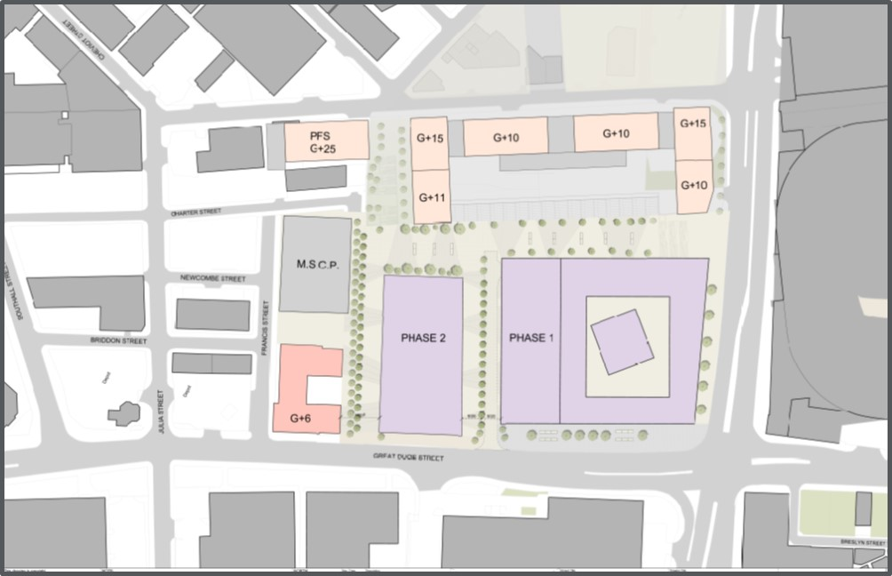

Consistency with the 2015 Strategic Regeneration Framework

The proposals above are consistent with the SRF in that:
- The development of the College campus will provide jobs in a highly accessible location
- The campus will make a much broader economic contribution, playing a key role in the delivery of the GM Skills Strategy, which itself is driven by the need to support economic activity and growth and help local people to access the new employment opportunities being created in the city
- The campus will serve a community need in providing access to a wide range of facilities available beyond the students and direct staff. Facilities will include theatres, restaurants, etc.
- The commitment to provide high quality public space is maintained
- The desire to provide car parking spaces is maintained. These will be modern, fit for purpose spaces, supporting the Council’s wider city centre car parking strategy
- There is opportunity, subject to the College’s long-term plans, to support the development of further higher quality residential units (and/or other commercial uses) to meet continuing strong demand in the city centre.

Design Principles

a) Uses

The Boddingtons SRF, and the subsequent Great Ducie Street SRF, seek to create opportunities to deliver a range of complementary uses that will combine to create a distinctive neighbourhood, with a clear sense of place, which will provide life and vitality during the working day and at evenings and weekends.

The opportunity to locate Manchester College’s City Centre Campus on this site, which will provide facilities delivering both Further Education and (through UCEN) Higher Education to a wide range of learners and clients from across the City of Manchester and beyond, clearly complements this ambition to deliver activity throughout the day - particularly when considered alongside the Old Brewery Gardens development, which received planning approval in 2018, and which will deliver five residential blocks providing a total of 556 homes and 3490 sq. m of commercial floor space.

This new Manchester College campus will create a fresh, innovative, sustainable and functional educational facility which will be at the forefront of further and higher education delivery in the UK. It will deliver creative curricula such as media, performing arts and visual arts as well as computing and digital media. The new building will contain state of the art performance, media and creative facilities reflective of the commercial sector and with the flexibility to grow, change and evolve. it will deliver business and professional, digital and creative education and also provide sixth form provision. In addition, the building will need to respond to employer and local business needs and provide commercially recognised facilities catering for local and national service industries.

The College will also have an outward facing, public presence, with training facilities such as a restaurant and hair salon providing services to the public, offered by College trainees. The public will also be able to access the heart of the building, with theatre and studio spaces being used to present public performances. The College will also encourage wider community access to some of the College facilities: with the performance spaces having the potential to offer flexible space for community events.

A multi storey car park will be retained within the illustrative masterplan. This is an essential component of the masterplan and will be required to service the Old Brewery Gardens development as well as to offset the loss of considerable surface parking on the SRF site which is currently well used by commuters and shoppers.

As mentioned above, should the College not progress with later phases of development and/or not require all of the land available for educational use, there may be scope to deliver other development. The uses would, in that case, be consistent with the 2015 Boddingtons SRF and might include residential, commercial or hotel development.

With proposals to phase development, there will be opportunity for temporary uses. This could include some continuation of the existing surface car parking (albeit at reduced numbers) but also opportunity to provide “pop up” activities. These uses should have regard to the amenity created and the setting for the College campus proposals and student, staff and visitor experience.

b) Density, Massing and Scale

The scale and massing of building form within the Boddingtons SRF area should respond to existing buildings in surrounding areas, to the indicative proposals contained within the Great Ducie Street SRF and to the approved Old Brewery Gardens scheme. The significant change in level across the site (there is a difference in excess of 10m between the levels on Dutton Street and on Great Ducie Street) has always been an important consideration in terms of scale. The Boddingtons SRF considered that this presented an opportunity for an increased number of storeys at the lower, Great Ducie Street, level.

The Boddingtons SRF, and the Great Ducie Street SRF, considered that the study area, as a gateway site located on key routes into Manchester city centre, may be an appropriate location for tall buildings, subject to development proposals being robustly justified in accordance with local and national planning guidance. Both documents suggested creating significant increases in density of development within the SRF area, whilst carefully mediating between the low scale buildings generally found to the north of the SRF area and the taller buildings which already exist and which are under construction to the south and west of the SRF area. The illustrative masterplan proposed increases in height to the perimeter of the SRF area and, particularly along Great Ducie Street and New Bridge Street.

The Old Brewery Gardens approval establishes a form of development along the north-eastern edge of the study area, with five tall residential buildings ranging from 16 storeys to 26 storeys arranged along the Dutton Street elevation, sitting above a two-storey podium.

The first phase of College development will be located to the south western edges of the Boddingtons SRF study area, addressing the Great Ducie Street and New Bridge Street frontages. The entrance to the College campus will be located on the New Bridge Street/Great Ducie Street corner of the site, addressing the approaches from the major public transport hubs adjacent, which it is anticipated that most learners will use to access the facility.

This important corner provides an opportunity to create a distinctive identity for the College, positioned on a major approach to the city centre and directly on Manchester’s Inner Relief Road, giving the opportunity to maximise potential ‘shopfronts’ on Great Ducie Street and New Bridge Street and create active frontages occupied by the College’s training restaurant and hair and beauty salon.

Later phase(s) of the College development will be located further north along Great Ducie Street. It is anticipated that the College building will be between six and eight storeys tall, considerably lower than the buildings shown on the illustrative masterplan accompanying the Boddingtons SRF.

It is important that the building offers a secure and welcoming environment for learners and the intention is that a private space will be created for students at the heart of the new College campus. Early iterations of the design have looked at creating a college building arranged around a central courtyard, or atrium, which will provide a secure space within which learners can gather and socialise. Access to amenity spaces on the roof of the College buildings will also be considered and the design of these spaces will need to be considered carefully in relation to both the privacy of adjacent residential developments and the safeguarding of College students.

In the event that the College does not progress with later phases of development and/or does not require all of the land available for educational use, there may be scope to deliver other development on the site between the College and the existing Travelodge and (proposed) Multi Storey Car Park on Francis Street. In that instance, there may be opportunities for delivery of a taller building on this site, addressing new connections north east across the site from the River Irwell, subject to a robust justification as referred to above.

c) Place Making and Public Realm

The College campus offers a unique opportunity to create something new for the City Centre; bringing a new mix of learners into the centre. It is vital that the design of the public realm within the study area reflects this; creating a distinctive image and ‘sense of place’ that sets the area apart from surrounding commercial and residential developments. Key aspects of this will be: creating a welcoming and secure environment that can offer learners a unique space within the City - a sanctuary for learning; and creating a welcoming and accessible design for the College that engages with the City at street level, showcasing and celebrating the activity within to ‘demystify’ access to education and help to inspire and attract new learners.

An appropriate landscaping scheme that creates a positive and welcoming character should be included as part of any development. This should be linked to a legible public realm strategy to create spaces that can be used by learners, residents and visitors to the area. This approach will pay dividends in creating an environment attractive to both residential and commercial occupiers.

The College building will have a considerably larger footprint than the smaller floorplate office and residential buildings shown in the 2015 Boddingtons SRF. This does have an impact on the public realm proposals.

The indicative masterplan included within the 2015 SRF proposed a tall residential building on the Great Ducie Street/New Bridge Street corner, with a public route which ran behind this tall residential building, parallel to Great Ducie Street, connecting into an east-west connection across the SRF study area. The nature of this east west connection has been changed by the Old Brewery Gardens proposal which concentrates movement onto the stepped connection to the north of the site, rather than providing a direct connection on this line up to Dutton Street. The updated masterplan which forms part of this addendum proposes setting the College building back from Great Ducie Street, creating a widened ‘plaza’ which acts as an entry point not only for the College but for the Boddingtons masterplan area as a whole.

This new public space will act as one of the key public spaces which help to deliver the ambitions of the Great Ducie Street SRF - to create improved pedestrian links east to west from the River Irwell to the River Irk via a network of high quality public spaces. It provides an arrival and orientation point for pedestrians approaching the site from the city centre/Victoria Station underneath the railway viaducts along Victoria Street. New pedestrian routes will connect this public space directly to new public spaces alongside the River Irwell and at the heart of the Boddingtons site, and from there, via the tiered steps approved as part of the Old Brewery gardens proposal, to Dutton Street and to potential new public spaces further to the north west around Park Place proposed under the Great Ducie Street framework.

The public realm proposals which have been approved as part of the Old Brewery Gardens scheme create a significant new landscaped space onto which the proposed commercial spaces within Old Brewery Gardens front. This scheme includes new lifts and stairs, in addition to those on Dutton Street, to address the significant changes in level to New Bridge Street and provide a connection from Victoria Station to the public space at the heart of the Boddingtons SRF area.

Developments should assist in mitigating the poor quality pedestrian environment currently created by the proximity of the Study Area to both Great Ducie Street and New Bridge Street through planting and other environmental improvements commensurate with their role as a gateway into the Study Area and on a key route into the City Centre, with a focus on introducing high quality frontages with attractive uses to encourage full integration of the Study Area with the City Centre and to draw people in.

The overall provision of public spaces across the whole site is shown in Figure 3 overleaf.

Figure 3: The range of public space and public realm across the whole of the Former Boddingtons Brewery Site
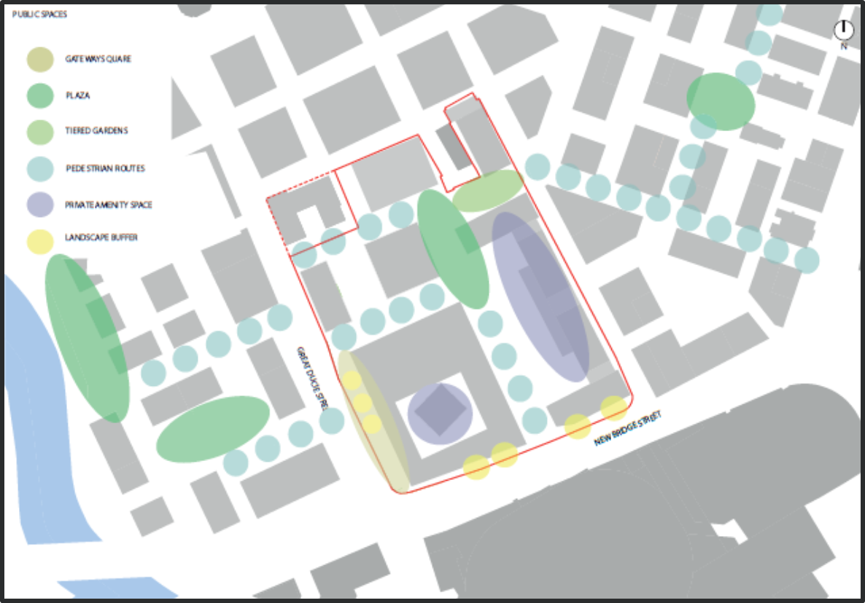

d) Connections

Re-establishing connections through the Study Area into the wider area will be important. The Illustrative Boddingtons Masterplan and the Great Ducie Street SRF both sought to integrate stronger north-south connections within the Study Area to facilitate movement between the Strangeways Employment Area to the North and the City Centre to the south and to open up east to west connections to provide alternative routes into the wider area, particularly in connecting the Irwell and the Irk and ensuring that the Study Area can interact fully with its surroundings. The development should be designed so that movements are clearly legible and accessible by all, providing an efficient network across the Study Area linking into the wider area.

Consideration also needs to be given to balancing the servicing needs of the College and adjacent developments with pedestrian/cycle movement through the site.

Strong connections are crucial for creating a neighbourhood which is attractive to occupants and the consideration of connections should extend to reviewing routes into the City Centre via the existing public highway system and, particularly, ensuring that there is safe, secure and appropriate pedestrian access across the Inner Ring Road to and from the core of the city centre and across Great Ducie Street towards the River Irwell. This is a key issue in encouraging movements both from the City Centre to the Study Area and vice versa.

Figure 4: Plan showing key connections across the whole of the Former Boddingtons Brewery Site
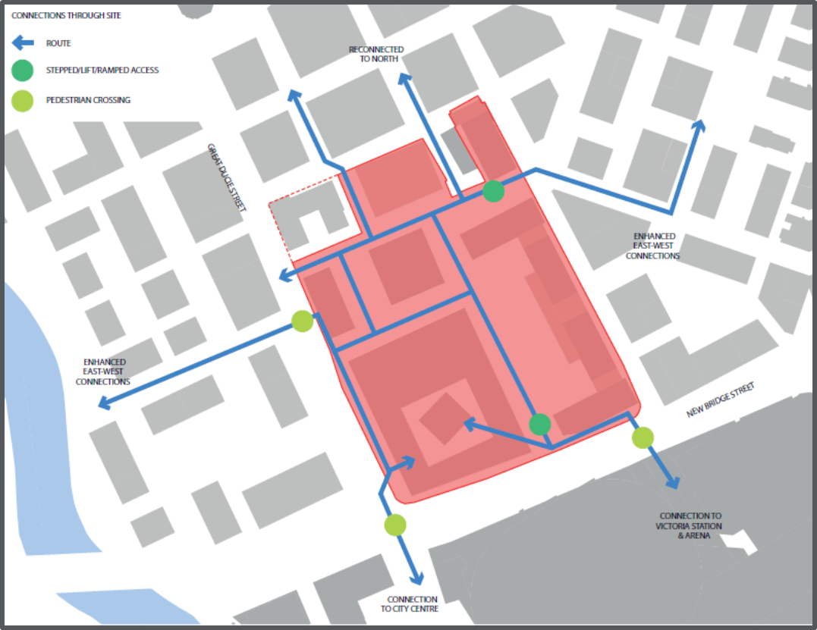

Delivery and Phasing

Delivery of the whole of the former Boddingtons Brewery site needs to be achieved comprehensively. The current proposals for delivering individual elements are these:
- The eastern part of the site is developed for residential use (by Prosperity)
- The College delivers its new campus, in a phased approach
- Realty Estates (as current site owner) will promote delivery of the Multi Storey Car Park.

The College will lead on any development of alternative uses if land is not required for future College development.

A comprehensive estate management arrangement will be put in place to deliver and maintain the quality public realm across the site. Contractual agreements have been entered into by the above partners to achieve this.

Phasing

As described above, the College proposes to phase development of its new campus. This may allow some temporary use of part of the site. Appropriate use could include continuation of the surface car parking and other appropriate “pop up” or temporary uses. Such uses need to have regard to local amenity, in particular the amenity enjoyed by the student, staff and visitors to the new College campus.

Appendix A: Related Policy Objectives

Detailed here are the further economic and planning policies and strategies that are now relevant to the development of the site. This includes discussion of the need for high quality further (and higher) education facilities in city centre Manchester.

a) Greater Manchester (GM) Work and Skills Strategy

The GM Work and Skills Strategy states that:

“GM needs a transformational education, skills and employment system that delivers the higher level and technical skills needed to drive productivity in GM’s growth sectors, and to deliver a step-change improvement in basic and generic skills, including English, maths and digital”

The College’s strategy and estate plans take account of the GM analysis of the curriculum mismatch with the skills needs of the priority growth sectors requires a modernised vocational/technical estate and the acceleration of closer working relationship between employers and key sectors and training providers. (ref. GM Work and Skills Strategy ‘Strengthening employer engagement’).

The College plans to increase the scale, accessibility and the quality of Level 3 provision and apprenticeships through specialist vocational centres of excellence, applying the co-design/co-delivery model, working closely with priority sectors to provide a more relevant and forward-looking level 2/3/4 study programme built around the needs of GM industry. (ref. GM Strategy ‘Delivering an employer-led skills programme’/GM ‘Work and Skills Strategy ‘Development of GM’s work and skills infrastructure to meet needs of the economy’/‘Growing the quality and quantity of apprenticeships’/’Developing higher level skills’).

New learning hubs will deliver targeted NEET (“Not In Employment, Education or Training”) prevention programmes, supporting individuals back into work through pre-employment training, IAG, English and Maths, quality work placements. (ref. GM Strategy ‘Preventing and reducing youth unemployment’ and ‘Delivering an integrated approach to employment and skills’).

The learning hubs will deliver a complex transitioning and support service, supporting significant volumes of learners at risk of becoming NEET. The learning hubs will offer an engagement curriculum for harder to reach learners. Pre-employment, IAG and welfare, and vocational/academic mentoring support will be provided. Basic Skills provision will be increased by 18%.

The new College estate directly responds to the workforce challenges identified in the New Economy Deep Dive Reports and responds to the sector identified in the Work and Skills Strategy.

Table 1: Greater Manchester Employment and Occupational Change
Employment Growth 2015-2034¹ | Jobs | Occupational Change 2014-2024 | Positions²
Professional Services | +42,627 | Managers, Directors and senior officials | 70,000
Financial and Business Services | +51,680 | Professional occupations | 137,000
Employment Services | +19,125 | Associate professional and technical | 76,000
Creative Industries | +10,362 | Skilled trades occupations | 32,000
Digital Industries | +11,235 | Caring, leisure other service occupations | 86,000
¹ New Economy Deep Dive Reports 2017
² Working Futures 2014

Despite recent growth, GM productivity levels continue to lag behind the national average, and this results in much lower household incomes.

Table 2: Greater Manchester Productivity In Key Sectors
GVA Per Person Employed
Sector | GM | UK | Sector | GM | UK
Business Services | £27,200 | £31,000 | Digital Industries | £66,200 | £73,900
Employment Activities | £23,400 | £28,300 | Creative Industries | £37,300 | £42,600
Financial Services | £66,800 | £103,200 | Advanced Manufacturing | £72,600 | £65,100
Professional Services | £78,100 | £99,700 | Other Manufacturing | £64,000 | £56,400
¹ New Economy Deep Dive Reports 2017

By 2024/25 College learner numbers will have increased to 6,540 16-18 year olds, 8,707 adult learners, and 2,000 higher education learners, supporting the growth of priority sectors.

Table 3: Contribution To Economic Growth 2022/23
Annual Growth  And Demand | Annual GVA  Growth¹ | Job Growth | Replacement Demand | TMC  Annual Supply of Completers
Professional Services | £390m | +2,131 | 4,000 | c. 5,000 level 3 completers and 800 level 4 completers  500 apprenticeships
Financial and Business Services | £430m | +2,582 | 6,000
Creative Industries | £70m | +518 | 1,000
Digital Industries | £130m | +560 | 1,000
Sport/Health and Wellbeing | £90m | +950 | 7,600
Construction | £95m | +950 | 4,000
Logistics | £50m | +250 | 3,700
¹ Source: New Economy Deep Dives and GMEF

On an annual basis the new TMC estate will respond to sector growth forecast and replacement demand, delivering ROI in terms of contribution to the Exchequer (25% increase in earnings and reduction in welfare payments).

The BIS Research Paper 228, “Measuring the Net Present Value of Further Education 2015”, produced a series of estimates for the wage premium and NPV of particular qualifications.

Table 4: Economic Value of Training
 | NPV | Wage Premium  3-5 years | NPV per total £ of all investment | IRR
Full Level 2 | £66,000 | 11% | 7 | 36%
Full Level 3 | £67,000 | 8% | 4 | 25%
Level 2 apprenticeship | £61,000 | 11% | 4 | 30%
Level 3 Apprenticeship | £88,000 | 16% | 3 | 23%
Source BIS Research Paper 228, 2015

The College’s estate strategy and proposed new facilities will significantly increase the scale and quality of learning provision, with an increased emphasis on the priority sectors. By 2024/25 learner numbers will have increased to 6,400 16-18 year olds, 6,600 adult learners, and 2,000 higher education learners.

Over a ten-year period the impact on the economy will be considerable and central to Greater Manchester delivering the economic and employment growth set out in the GM Accelerated Growth Scenario delivering productive growth and inclusive growth.

b) Manchester College Estate Strategy, 2017-2022

The College’s estate strategy was approved by the College Governing Body in September 2016 and it was endorsed by the Council Executive on 15 November 2017.

The Strategy consolidates the Manchester College’s estate to five sites. The plan includes a new campus in the city centre and significant remodelling and investment at the Openshaw Campus. These will significantly improve the quality and attractiveness of the learning offer for residents and employers. The Estates Strategy also has the potential to reduce operational costs, while increasing the number of learners supported.

As a result of the strategy, the College will exit and vacate 20 existing properties, of various sizes, occupied under various tenures. This includes some significant freehold properties. The “target” estate will create leading edge technical and vocational facilities for post 16 education.

CITY CENTRE
Campus focusing on Creative & Digital and Business, Financial & Professional Services, where the majority of Manchester’s employment growth is expected, and new markets and technological change require a higher skilled workforce. The City Centre site will accommodate the College’s A level centre, providing academic routes into Higher Education
CITY LABS (CITY CENTRE 2)
Access to Medical Sciences Centre of Excellence at City Labs, located in the city centre within the Corridor Manchester health cluster.
OPENSHAW
Campus focusing on Construction and Logistics, plus Sport, Health and Wellbeing, including health, social care and childcare. Serving east Manchester, the campus would also offer an engagement curriculum for harder to reach learners or those who have not yet determined a route into specialisation. A broader curriculum offer would provide pre-employment, information, advice and guidance and welfare.
WYTHENSHAWE
Serving south Manchester, the Wythenshawe campus would offer an engagement curriculum for harder to reach learners or those who have not yet determined a route into specialisation. A broader curriculum offer would provide pre- employment, information, advice and guidance and welfare.

HARPURHEY
Serving north Manchester, Harpurhey would offer an engagement curriculum for harder to reach learners or those who have not yet determined
a route into specialisation. A broader curriculum offer would provide pre-employment, information, advice and guidance and welfare

The new city centre campus will provide a total of around 30,000 sq m of new floorspace. As well as classroom and office accommodation, facilities would include a bistro, a hair and beauty salon, cafes, library and learning centres, art and design studios, digital and computing suites, dance studios and a theatre.

The city centre campus would be home to around 8,000 students, divided approximately between 3,000 16-18-year olds, 1,500 higher education students and 3,500 adult learners.

The College, its learners, staff and activities will bring significant vitality and spending power to the city centre.
The curriculum areas planned to be located at the new city centre campus would be:

- Business, Finance and Professional Services.
- Creative and Digital.
- GCSE A Levels.
The campus will be funded through a combination of College own resources, Skills Capital Grant (from the Combined Authority), capital receipts from the sale of surplus land and bank borrowing.

There is a need to phase the release of Skills Capital Grant and so the construction of the city centre -campus will itself need to be phased. Phase 1 will be a building of 20,000 sq m and facilities will include a theatre, restaurant and hair and beauty salon. Phase 2 will be of around 10,000 sq m.

c) Housing Strategy and Housing Market

In the event that the College does not require all of the site acquired for College use, alternative uses may be brought forward. This would include housing.

Policy H8 of the Local Plan sets out the requirements for affordable housing or an equivalent financial contribution. This currently applies to all residential developments on sites of 0.3 hectares and above or where 15 or more units are proposed. Further detail is included in “Providing for Housing Choice SPD (2008)”.

Providing Housing Choice (2008) - Supplementary Planning Document & Planning Guidance

This sets out the guideline for the provision of affordable housing in Manchester City Council’s authority: developments of 15 or more dwellings. Based on an average assumed density of 50 dwellings per hectare, this will also apply to sites of 0.3 hectares and larger. The gross developable area of the site, as shown on the planning application, will be applied. If affordable housing is inappropriate on a site which is larger than 0.3 Ha because there are less than 15 units, payment of a commuted sum by a developer will be acceptable instead. This guidance proposes a City-wide target for 20% of new housing provision to be affordable housing (the number of units will be rounded to the nearest whole number). On development sites which are larger than the thresholds set out in paragraph 5.4 the Council will expect developers to use the 20% target as a starting point for calculating affordable housing provision. 5% of new housing provision will be social rented, a further 15% of the new housing provision is envisaged to be intermediate housing, delivering affordable home ownership options. The Council aims to achieve mixed tenure developments where the affordable housing units are truly integrated into the overall scheme.
D) Car Parking Strategy

The site provides significant surface car parking but the Council do not consider this to be an appropriate long-term use and the current parking operates under a time limited planning permission.

There is other car parking in the vicinity, notably some 950 spaces in the Manchester Arena Car Park immediately across the Inner Ring Road from the subject site.

It is noted that some pressures for car parking use are changing. A growing number of occupants of city centre apartments are no longer requiring access to car parking spaces. Further the city will seek to reduce car use as part of its move to a Zero Carbon city by 2038. There is also the prospect of driverless vehicle technology in the relatively near future.

The case for car parking as part of any development needs to reflect these trends and changing policy positions. Further, any car park, including a multi storey car park, needs to be designed with future requirements in mind. This would include, for example, a significant increase in electric charging points above current norms.

e) Great Ducie Street Strategic Regeneration Framework

The Great Ducie Street SRF was considered by the Council’s Executive in August 2018 and was then subject to public consultation. Its focus is the area to the north of the Trinity Way. It specifically excludes the former Boddingtons site but abuts the site to the west, north and east.

Key aspects of the SRF are outlined in Table 5.

Table 5: Key features of the Great Ducie Street SRF
“Overall, the SRF area represents an opportunity to create a genuinely mixed-use neighbourhood with a strong sense of place and community, which reflects on the principle set by the former Boddington’s Brewery SRF to deliver a maximum of 50% residential accommodation with the SRF area with the balance comprising non-residential uses.”

Other key principles include:
- Creating a significant increase in density of development within the SRF area, whilst carefully mediating between the low scale buildings generally found to the north of the SRF area and the taller buildings which exist and which are under construction to the south and west of the SRF area.
- Providing more and better employment floorspace, enhancing and expanding the commercial bas and potential of the Strangeways area.
- Providing High quality, sustainable new homes
- Creating improvements to public realm, including the improvement of the pedestrian environment along the significant vehicular routes which bisect the SRF area - Great Ducie Street, Trinity Way and New Bridge Street.
- Providing better connections to the River Irwell, and better and safer pedestrian routes along the Irwell, including the creation of a significant new public space adjacent to the River, through the closure/pedestrianisation of part of Mary Street, at the heart of a significant new residential/commercial development.
- Creating improved pedestrian links east to west across the SRF area, providing alternatives to the busy arterial routes for pedestrians/cyclists and providing new connections, via a network of high quality public spaces from the River Irwell to the River Irk.

